STUDY ON THE NIGERIA NON-OIL EXPORT SECTOR

Table of Contents
TABLES 2
FIGURES 3
EXECUTIVE SUMMARY 4
Section 1: Overview of The Nigeria Economy 6
1.1 The Zero Oil Plan 6
1.2 Agriculture Promotion Policy 8
1.3 National Enterprise Development Programme/One-Local Government-One Product (NEDEP/OLOP) 9

Section 2: Factors Inhibiting Actualisation Of True Export Potentials 11
2.1 Information Factors 11
2.2 Resource Factors 11
2.3 Procedural Factors 11
2.4 External Factors 12

Section 3: Potential/ Opportunities of Our Non-Oil Export 13
3.0 Introduction 13
3.1 Potential Quick Wins/ Low Hanging Fruits 13
3.2 Rising World Population as An Opportunity for Nigeria 15
3.3 Medium Term Opportunities 16
3.4 Long Term Opportunities 17

Section 4: Targeted Policy and Institutional Reforms 19
4.0 Introduction 19
4.1 Building Non-Oil Exports: The Need for Export Incentives 19
4.2 Supporting Non-oil Export through Incentives: Examples from
Other Countries 22
4.3 The Export Expansion Grant (EEG) 27
4.4 Resolving the Impasse 31
4.5 Renegotiate unutilized NDCCs and Claims-in-the-Pipeline 32
4.6 Policy Stability and Continuity 33
4.7 Involving the State Governments 33
4.8 Recommendation 34
4.9 Regular Consultation between the Government and the Private Sector 37

Section 5: Spurring Trade Growth Through a New Trade
Facilitation Agreement 40
5.1 Introduction 40
5.2: Trade Performance of Nigeria 41
5.3 Basic Description of WTO Trade Facilitation Agreements 46
5.4 TFA and Implementation Challenges 49
5.5 Factors for the Implementation of TFA 53

Section 6: Summary and Conclusion 59
Tables

Table 1.1 Misalignment between the Zero Oil plan and Agriculture
Promotion Policy 8
Table 3.1 Top ten non-oil export earners from 2011-2015 13
Table 3.2: Nigeria Export Destination 15
Table 3.3: Selected Nigeria Exports 16
Table 4.1 Comparison of Financial cost between Nigeria and
some of her export Competitors 20
Table 4.2 World Bank Group: 2015 Doing Business ranking data
for Nigeria and Selected countries 22
Table 5.1: Trade Performance of Nigeria 42
Table 5.2: Structure of Nigeria’s Trade 44
Table 5.3: Nigeria’s Export to Ten Destinations
in the world (US$ million) 45

Figures

Figure 1: Comparison of Financial cost between Nigeria and
some of her export Competitors 21
Figure 2: Benefits of EEG 28
Figure 3: Impact of EEG on Non-oil Exports 28
Figure 4: Nigeria non-oil remittances 29
Figure 6: Employment in non-oil sector 30
Figure 7: Potential non-oil exports across Nigeria 30
Figure 8: Destination of Nigeria’s non-oil export 31
Figure 9: Value of Nigeria non-oil exports (2006-2014) 31
Figure 10: Policy on EEG (2005-2011 33
Figure 11: Trade Facilitation and Broader Policy Initiatives 40
Figure 12: Trend of Imports and Exports in Nigeria 2003 – 2015 43
Figure 13: Product and Market Diversification of
ECOWAS Member States 46
Figure 14: Main Success Factors Reported in Case Studies on
Trade Facilitation 54
Figure 15: Relevant Stakeholders in TFA implementation 55

EXECUTIVE SUMMARY
That the Nigerian economy is structurally deficient is not just a statistical fact, but a daily practical experience by many! While this reality is also compounded by the inapt, weak and often cloudy policy stances of past administration, the sole culprit, has viewed by analyst, is the awkward structure upon which the economic foundation is based. Over the years, this challenge has manifested itself in different ways namely low domestic capacity, marginal contribution of industrial sector national output, massive importation and the attendant impacts on the fiscal balance, chronic youth unemployment and exclusiveness.
Recently, the Nigerian economy plunged into recession with woeful performance across all major economic indicators. The economy experienced a negative growth of -1.5%. Inflation rate closed the year at 18.55% from 9% in January, 2017. Unemployment rate also increased to 13.9% in the third quarter of the year 2016 from 10.4% in the fourth quarter of 2015.
The need for recovery and growth after the challenge of economic recession, thus, becomes more evident. To arrest the trend, the federal government launched the National Economic Recovery and Growth Plan (NERGP), a 4-year Medium Term Plan (2017-2020). The is a strategic document which details 24 programmes, 60 strategies with 5 key execution articulates three objectives, namely restoring growth, investing in the people and building a competitive economy. Achieving macroeconomic stability and economic diversification presumes the need for policy focus on the key sectors in order to achieve domestic sufficiency and promote export. This lofty ambition primarily summarises the spirit behind the made-in-Nigeria campaign and subsequently the ERG Plan.

This study on the export potentials of Nigeria is born out of this necessity, to highlight the undercurrents and develop strategies for realising sustainable non-oil export push. It proffers extensive perspectives and propositions on export promotion and economic diversification in Nigeria. It delves into critical discussions around evaluation of conditions that must be considered and strategies that must be explored in enhancing non-oil sector export. Bearing in mind the strategic role of regulation and institutions in fostering export-enhancing initiatives, the study examines and recommends trade reforms. More specifically, the following key points are leveraged in this study:
- Section 1 reviews the current state of the economy
- Section 2 explores the economic diversification agenda, self-sufficiency enhancement and export push strategy/initiatives with a special focus on the Nigerian Export Promotion Council (NEPC) launched initiative of Zero Oil Plan in October 2016, the Agriculture Promotion Policy (APP) and the National Enterprise Development Programme/One-Local Government-One Product (NEDEP/OLOP).
- Section 3 considers the factors inhibiting actualisation of true export potentials
- Chapter 4 highlights potentials and opportunities of non-oil export
- Section suggests targeted policy and institutional reforms

SECTION 1: OVERVIEW OF THE NIGERIA ECONOMY
Nigeria is a paradox. Despite being blessed with abundant human and natural resources, over 50% of its population live on less than a dollar per day.

The Nigeria economy that once prided itself in the abundance of natural resources in forms ready for use by industrial concerns and as such the scramble and partitioning by European powers post -colonial era was essentially a scramble for the abundant mineral and other essential natural resources we were and still are blessed with but sadly, over half a century after independence, we still have cringed to a mono-economy with its attendant consequences on macroeconomic performance.

Obviously, Nigeria has earned substantial revenue from the oil sector since independence but failed to see beyond the immediate and expand its revenue streams into other sectors where there lies comparative advantage. The agriculture and solid minerals sectors, our non-oil export witnessed neglect from both the private and public sector, this is has been confirmed by investment inflows into the oil sector as against inflows into the non-oil sector.

Unfortunately, oil price in international market fell precipitously to less than US$30 a barrel in 2016, in continuation of cascading price that started in 2014. Consequently, oil revenue receipts fell by almost 50%. The precarious situations triggered multi-dimensional socio-economic crisis. As oil revenue continue to suffer, the external reserve declined to below US$25 billion, and the apex bank could no longer defend the naira. After tremendous pressure on the apex, CBN introduced a floated FX system coupled with other interventions to enhance the value of the naira, unfortunately, the naira continue to suffer serial attacks. The greenback became more scarce and the naira depreciated continuously at the parallel market segment.

Against this backdrop, Nigeria's real Gross Domestic Product (GDP) contracted by 1.6% in 2016, a far cry from 2.76% growth rate recorded in 2015. Thus, the economy plunge into stagflation with inflation rising to 18.6% followed by increasing unemployment and underemployment at 13.9% and 19.7% respectively. Foreign trade performance was discouraging as value of exports decreased by ₦24.4 billion or 1.0% in the third quarter 2016 coupled with attendant trade deficit. The worrisome dimension however is that crude oil remains the mainstay of our export constituting about 84% of our total exports. The Nigerian economy has remained one with huge potential beyond oil and will no doubt improve on all fronts should we look beyond oil and take deliberate steps to improve our fortunes from the non-oil sector via putting in place the right structures, policies, investments and drive essential to improving our non-oil revenue earnings.

In an effort to redirect our path and change the narratives, the federal government embark on diversification agenda, to reduce the dependence of the economy on oil and build buffer against external shocks, price volatility and aftermath of oil glut. At the heart of the economic diversification agenda, is self-sufficiency enhancement and export push strategy.

1.1 The Zero Oil Plan
In this view, the Nigerian Export Promotion Council (NEPC) launched the Zero Oil Plan in October 2016 with the following objectives;
- To grow foreign reserves to exceed $150 million over the next decade from non-oil exports alone;
- To create 500,000 additional export based jobs annually; and
- Get at least 10 million Nigerians out of poverty in the next decade from export activities alone.

The “Zero Oil” plan seen as the first coherent agenda to mobilize public and private resources towards replacing oil as major source of foreign exchange. The plan articulates by carefully selecting priority sectors, sectors that have the potential to galvanise sufficient income. Through a carefully regional and product mapping, Nigeria is set to gain a minimum 5% share over the next ten years in the following commodities: Petrochemicals & Methanol, Soyabeans, and Soyabeans Meal and Oil, Sugar (raw, cane, and confectionary), Cotton and Yarn, Nitrogenous Fertilizer and Ammonia, Palm Oil, Rice, Rubber, Hides and Leather, Cocoa (beans, paste, butter, powder), and 0.5% share in Gold.

Specifically, the crop focus for the zero oil plan were listed as
- Palm oil
- Cocoa
- Cotton
- Leather
- Petro Chemicals
- Nitrogenous Fertilizer
- Cement
- Gold
- Soybeans
- Rubber
- Cashew
- Ginger and spices
- Sesame seeds

After a cursory examination of the above listed crops, we observe the following shortcomings:

- Structural Approach
The zero oil plans success is hugely dependent on state governments validating the plan, develop requirements to drive the plan at the states and mobilize resources for its implementation across the states, thus, several months after its launch, NEPC is still waiting on state governments to carry out the assigned responsibilities for the initiative’s smooth take-off. A far better and pragmatic approach would have been to co-create the plan with the state governments with a view to having a consensus before its adoption, this way NEPC would have launched a plan accepted across board.

- Absence of A Needs Analysis
The APP intends to drive up palm oil production for export by 20 million tons within no given time period neither does it provide insight into what mechanisms are put or will be put in place to bring to reality this bump in palm oil production for export.

A needs analysis of why our palm oil production both for local consumption and export has been consistently declining in the past years should have been undertaking by NEPC with a view to determining what urgent steps needs be taken to reverse the ugly trend.

- Absence of Clear Understanding of Funding Needs
The APP projects that a budgetary allocation of between ₦144-₦192 billion should be earmarked to facilitate, de-risk and or accelerate export oriented projects but provides no details on how it arrived at the sum and to what exact activities it will be channelled to, should such budgetary allocation be received.

The absence of a clear understanding of what funding needs are required by relevant agencies of government to spur significant increase in non-oil export is indicative of the inability of the agencies to understand what the specific challenges are and how they will be surmounted.

- Policy Focus
The zero-oil plan seek to focus more on crops where we have greater comparative advantage as against crops from which we have been earning some measure of sustained foreign exchange from, at least in the short term. The shortcoming here is that NEPC might be unable to spur significant production of the crops with greater comparative advantage for us in the short term as much as it would spur significant increase in foreign exchange earnings had it focused on our current top ten non-oil exports.

It is also worthy of note that the plan which was launched in October 2016, four months after the launch of the Green Alternative (Agriculture Promotion Policy) is not aligned to the focus areas of the Federal Ministry of Agriculture as its focus crops are at some level of variance with that of the ministry.

Table 1.1 Misalignment between the Zero Oil plan and Agriculture Promotion Policy

SN | ZERO OIL PLAN | AGRICULTURE PROMOTION POLICY
1 | Palm Oil | Rice
2 | Cocoa | Wheat
3 | Cotton | Maize
4 | Leather | Aquaculture
5 | Petro Chemicals | Diary Milk
6 | Nitrogenous Fertiliser | Soya Milk
7 | Cement | Poultry
8 | Gold | Horticulture
9 | Soya Beans | Sugar

Data provided above clearly indicates that the resources available to the ministry (both from budgetary allocations and from donor agencies) will be used to pursue an agenda at variance with that of the Zero oil plan as NEPC will channel all its resources to promote non-oil export that might largely not be produced in Nigeria as the role of NEPC basically is promotion of non-oil exports produced in Nigeria and not the production of the non-oil export goods.

1.2 Agriculture Promotion Policy
The Agricultural Transformation Agenda of the Jonathan Administration was replaced by the Agriculture Promotion Policy (APP) and had as its primary objective the provision of a disciplined approach to building an agribusiness ecosystem that will solve the challenges of high food imports and inability to earn significant foreign exchange from agriculture.

The APP though well intentioned lacks the sort of depth expected of it as it failed to address the following fundamentals challenges:

Firstly, the Nigerian Agricultural Research Services (NARS) with fifteen (15) commodity based research institutions, eleven (11) federal colleges of agriculture, a specialised national agriculture extension institute, over fifty (50) faculties of agriculture in federal universities and three (3) specialised universities of agriculture has consistently failed to provide up to date information and research findings that will aid food production, either for local consumption or for export and the APP provides no clue on how it intends revive NARS to enable it drive the non-oil export campaigns/projections.

Secondly, the APP talks about engaging a new generation of farmers to help drive the policy but provides no information on how it intends to do this seeing clearly that we do not have any deliberate youth in agriculture policy or any specific target on bringing more Nigerians into commercial agricultural enterprises. The inability of the ministry to engage new generation of farmers to drive the Cassava bread initiative was a clear indication of how much work needs to be done with a view to learning why our agriculture sector has failed to attract new entrants especially our unemployed youths.

In addition, the APP indicates efforts will be made to create special funds such as the planned ₦10 billion Cassava fund and Fafin/KFW €35 million facility to drive our production for non-oil export, the crops it has taken as priority crops but fails to indicate if it has undertaken a monitoring, evaluation, research and learning (MERL) to determine why such initiatives as the Cassava bread initiative, CBN ₦220 billion MSMEDF, CBN/NEXIM ₦300 billion real sector support fund and OLOP have all failed to impact positively on our non-oil export production.

1.3 National Enterprise Development Programme/One-Local Government-One Product (NEDEP/OLOP)
NEDEP was launched in February 2014 as a component of the National Industrial Revolution Plan (NIRP) and was meant to spur local production of goods as a means of reducing our import bills for goods we can locally produce in Nigeria. A good initiative it would seem, but as is often the case, the policy was bereft of the depth it should have and implementation approach was faulty.

NEDEP/OLOP had no structured approach on how funding would be secured for the entities that would be producing the products across the various local governments and also had no platform for identifying what products can be produced at the local governments and how to support their production.

NEDEP/OLOP was not designed to advance our production of goods already accepted in both local and foreign markets neither was it conceived to work in partnership with either NEPC or the Federal Ministry of Agriculture to determine the best approach to driving the initiative and as such, two years after its launch, the initiative had little or no success to report and today has joined the list of failed intervention initiatives designed to drive our non-oil export.

The inability of the funding interventions/initiatives listed above to significantly improve our non-oil export is an indication of the existence of other deep rooted issues that urgently needs to be addressed, issues such as having a geo-mapping across all sub-sectors of our agricultural sector with a comprehensive audit of existing production capacity and to forecast required investment with a view to determining the best way to support each sub-sector, this would provide insights into what sort of financing services is needed by each sub-sector and what combination of non-financial intervention is needed by each to thrive.

SECTION 2: FACTORS INHIBITING ACTUALISATION OF TRUE EXPORT POTENTIALS
With the prevailing economic recession, the need to diversify the economy from oil to non-oil export has become more critical. This has remained the avowed focus of the federal government with the intention that development of the non-oil export process would serve as catalyst to revamp the ailing economy.
Having identified non-oil export as a leading priority for economic recovery, government has over the years deployed several attempts to develop export oriented trade strategies and stimulus to encourage export expansion.
However, the desire for export promotion is hindered by the following barriers that require constructive intervention to achieve the strategic economic objective:
  - Information Factors
- Lack of information relating to export activity
- Lack of knowledge about foreign markets
- Identifying opportunities in export markets
- Lack of awareness of export assistance
- Lack of awareness of benefits of export markets
- Lack of knowledge of best potential markets
- Lack of qualified staff
- Lack of knowledge of how to enter the export market

  - Resource Factors
- Lack of financial capacity
- Inadequate and inefficient infrastructure
- Lack of personnel to devote time on export activities
- Difficult to access and high interest rate on export funds
- Internal constraints like honouring letters of credit
- Reliance on external support resources like banks.
- Absence of in-country capacity for processing and high quality packaging
- Lack of sufficient mechanised capacity for high volume agricultural production

  - Procedural Factors
- Lengthy and cumbersome documentation process on export (Red tape)
- Import tariffs in destination export market
- Non-tariff barriers (technical barriers)
- Multiplicity of regulatory and security agencies at the ports
- High duplicated terminal/shipping company charge and process
- Logistics and distribution difficulties in foreign markets
- Proliferation of government agencies on the road and at the point of shipment
- Difficulty of finding a trustworthy distributor

  - External Factors
- Forex issues
- Difficulty of finding a trustworthy distributor in the foreign country
- Policy somersaults and unpredictable operating environments
- Inadequate export promotion incentives
- Lack of availability of capital for meaningful investment in these sectors
- Lack of socio-economic infrastructure
- Lack of dedicated attention to the market opportunities that exist
- Lack of effective export marketing

SECTION 3: POTENTIAL/ OPPORTUNITIES OF OUR NON-OIL EXPORT
3.0 Introduction
The Nigeria agriculture research services has in its fold; fifteen (15) commodity based research institutions, eleven (11) federal colleges of agriculture, a specialised national agriculture extension institute, over fifty (50) faculties of agriculture in federal universities and three (3) specialised universities of agriculture (1), the combination of the above should have placed Nigeria in an advantageous position to tackle food security challenges, improve our production for export of non-oil goods and place Nigeria in the committee of nations earning huge returns from non-oil export.
Nigeria is also recorded to have in its employ at the agriculture research and development institutes over five hundred (500) full-time equivalent researchers (2)and this represents the highest number employed by any African country but in terms of input/ research breakthroughs for the agribusiness industry in Nigeria, the country still lacks behind in yield per hectare across the continent.
The Nigerian non-oil export space in the last five years has witnessed a relatively decline in total value of export earnings and it is unclear what factors are responsible for the decline; if it is a function of declining production of the crops or a decline in the market demand for same, what is however clear is that on the average, we have earned less revenue from our non-oil exports from 2011-2015, this is sadly in contrast with the potential/ opportunities that abound for Nigeria in the non-oil export space.

3.1 Potential Quick Wins/ Low Hanging Fruits
Table 3.1 The table below itemises our top ten non-oil export earners from 2011-2015
S/NO | EXPORTED PRODUCTS | GROSS WEIGHT (MT) | EXPORT VALUE (USD) | % OF TOTAL VALUE
1 | COCOA BEANS | 24,519.80 | 338,176,992.99 | 20.82
2 | SESAME SEEDS | 185,953.68 | 240,011,169.96 | 14.77
3 | LEATHER | 3,559.26 | 145,269,547.62 | 8.94
4 | CIGARETTES | 10,456.27 | 98,363,810.04 | 6.05
5 | COCOA BUTTER | 10,279.10 | 67,891,150.92 | 4.18
6 | FORZEN SEA FOOD | 26,399.80 | 59,311,647.38 | 3.65
7 | ALUMINIUM INGOT | 26,113.20 | 47,122,688.74 | 2.90
8 | TIN ALLOYS | 2,817.80 | 46,869,253.52 | 2.89
9 | RUBBER | 35,063.70 | 45,655,104.11 | 2.81
10 | CASHEW NUTS | 55,119.31 | 42,016,207.07 | 2.59
Source: Nigeria Export Promotion Council
Cocoa beans has a sustained and continuing increase in its demand the world over and Nigeria ranks as one of the top producers of the crop and our potential to improve on our production of the crop is not in doubt, what however seems to be in doubt is our readiness to commit to improving our production of the crop in the right conditions as demanded by the export market for it.
The demand the world over for sesame seeds is also increasing and as is the case with cocoa beans, Nigeria still ranks as one countries with huge production potential for the crop and it is estimated that the potential to move from 185,953.68 MT production as at 2015 to well over 300,000MT within a two year period is realistic if only the right investments are made and enabling ecosystem provided for producers of sesame seeds in Nigeria and also importantly, right connections made between our producers and the export market for same.
The demand for leather will most assuredly continue to rise the world over in the foreseeable future as the need and use of it will continue to rise and as with both cocoa beans and sesame seeds, Nigeria has a huge potential for the production of leather and more so, with the existence of two specialised research institutes saddled with the responsibility of improving our sourcing and production of leather in Nigeria, our production of lather can be tripled in the minimum within the next three years if and when the right investments and structures are put in place to drive this.
The Nigerian government would have been expected to think through a mechanism that would be put in place to drive the process of improving on our non-oil export especially for the present top ten non-oil revenue earners as at 2015, rather than to plan to commit resources on exploring a new set of crops presently not among our top ten non-oil export earners on the argument that we have comparative advantage in their production.
The top ten non-oil export earners for Nigeria as at 2015 represent our low hanging fruits/ quick wins and combined together, earned us a total of one billion, one hundred and thirty million, six hundred and eighty seven thousand, five hundred and seventy two dollars and thirty five cents ($1,130,687,572.35) in 2015 alone, this figure can well be improved upon if more emphasis is placed on improving our yield per hectare for the top ten non-oil export earners and providing the right set of support for the individual entities contributing to this crops.
Our potential for earning greater returns from our non-oil export in Nigeria can be improved upon if our cropping intensity (which is the number of crop harvests per cell per year) is improved upon. Cropping intensity is highest in irrigated regions or in wetland areas such as southern Nigeria but the challenge has remained government insensitivity in mapping out approaches to improving on our cropping intensity to enable increased production of our present top ten non-oil export earners.

3.2 Rising World Population as An Opportunity for Nigeria
It is expected that the world’s population would rise to about eight billion five hundred million (8.5bn) persons by 2030 (3) and that the countries more likely to witness more population growth are among the present top ten country destination for our non-oil export.

Table 3.2: Nigeria Export Destination
S/NO | DESTINATION | GROSS WEIGHT (MT) | EXPORT VALUE(USD) | % VALUE
1 | NETHERLANDS | 145,696.80 | 364,288,098.32 | 22.42
2 | INDIA | 46,487.52 | 118,546,415,66 | 7.30
3 | GHANA | 261,089.72 | 113,305,872.17 | 6.97
4 | JAPAN | 65,005.60 | 93,337,783.61 | 5.75
5 | ITALY | 13,082.90 | 79,165,816.29 | 4.87
6 | TURKEY | 63,937.34 | 71,389,729.73 | 4.39
7 | GERMANY | 41,068.14 | 66,766,049.27 | 4.11
8 | CHINA | 68,472.94 | 56,441,181.62 | 3.74
9 | NIGER | 93,783.05 | 52,919473.07 | 3.26
10 | SOUTH KOREA | 21,031.80 | 50,584,862.68 | 3.11
Source: Nigeria Export Promotion Council
The table below shows the top 10 countries importing non-oil goods from Nigeria for 2015
India has a population of well over one billion three hundred (1,3bn) persons as at 2015 and is expected to have a population of about one billion five hundred (1.5bn) (4) persons by 2030 and with the country standing as the second importer of our non-oil export as at 2015, there clearly exist a potential for the country to increase its purchase of our non-oil export in the coming years if it finds them attractive enough and the task well ahead for the Nigerian government is to ensure our non-oil export presently been imported by India remains and continues to improve for the country to keep patronising us.
The combined population growth estimation for Netherlands, Ghana, Japan, Italy, Turkey and Germany by 2030 is estimated at four hundred and eleven million, six hundred and fifty thousand, seven hundred and twenty (411,650,720) (5) and with rising population most definitely comes rising food demands and presenting Nigeria with a huge potential for improved earnings from our non-oil export, but again, we need to understand the dynamics behind the market demand for non-oil exports the world over.
Rising world population presents Nigeria with a huge potential for improved non-oil export earnings as the demand for food would continue to increase across the world and the demand will come with it huge food import demand from countries with less food production capabilities than Nigeria, the potentials will translate to export earnings if and when our Nigeria Agriculture Research Services (NARS) contributes its quota to the drive to improve our cropping intensity and our National Agriculture Resilience Framework (NARF) is improved upon to enable us adapt to climate smart agriculture and help small holder farmers improve their growing conditions to adequately address the challenges of climate changes on agribusiness.

3.3 Medium Term Opportunities
The Zero oil plan as produced by the Nigeria Export Promotion Council seeks to place greater attention going forward on crops for which Nigeria has greater comparative advantage and for which it is projected that more foreign exchange can be earned by the country, the Zero oil plan should represent the medium term opportunities for the Nigerian state as it seeks avenues to improve on its foreign exchange earnings from non-oil exports.
Our medium term opportunities should focus on crops for which little or no foreign exchange is presently been earned but for which Nigeria has great potential to earn significant foreign exchange from, the crops are as listed below;
Table 3.3: Selected Nigeria Exports
Palm Oil
Cocoa
Cotton
Leather
Petrochemicals
Nitrogenous Fertilizer
Cement
Gold
Soybeans
Rubber
Cashews
Ginger & Spices
Sesame
Source: Nigeria Export Promotion Council

The crops listed above have huge export potentials and are presently not earning significant foreign exchange for Nigeria; it is our contention that these crops should be in our/NEPC medium term plans and not short term, reason largely been that we presently do not have the right structures/ecosystem to support the production of these crops and shifting emphasis from the present top ten foreign exchange earners to these crops for which we project to have greater comparative advantage might not turn out well for the country.
Our medium term opportunities as listed above should receive a great deal of support and planning from all relevant agencies of government to enable the provision of the right ecosystem that would encourage and support the production of the crops that have medium term opportunities for earning significant foreign exchange for the country.
It should also be noted that these potential can only be tapped into by the Nigerian state if the right structures are put in place, we must be able to improve first on the present top ten foreign exchange earners for us before thinking of the crops for which we have comparative advantage but presently do not have the enabling ecosystem for their production.

3.4 Long Term Opportunities
The Nigerian state can do well to put up enabling structures to facilitate the following that will enable it sustain its earnings from non-oil export in the long term;
- Restructure and reposition the Nigeria Agriculture Research Services
- Operationalize the Nigeria Agriculture Resilience Framework
- Operationalize the National Quality Control Policy

We would not need to add more crops beyond those in our short and medium term to list of crops that would earn foreign exchange for Nigeria; rather, emphasis should be on restructuring and repositioning the Nigeria Agriculture Research Services to enable the various commodities research institutes in Nigeria support the agribusiness sector with the right set of knowledge, skills and research findings that would enable the sector continue to remain relevant in the non-oil export international market.
Operationalizing the Nigeria Agriculture Resilience Framework will help our agribusiness sector understand the risk, challenges and opportunities climate change presents for our non-oil export market. The Federal Ministry of Agriculture and Rural Development should as a matter of urgency operationalize the Agriculture resilience framework to ensure entities producing our non-oil export goods clearly understand the challenges and opportunities climate change presents for their enterprises.
The National quality control policy of the Federal Ministry of Agriculture and Rural Development should also as a matter of urgency be launched and its contents made public and extension officials of the ministry take steps to enable our non-oil export producers understand the market demands on their products in the key areas of product standards and packaging. The absence of the quality control policy constitutes a great challenge to our non-oil export earning potentials, continuing decline in the standards/quality of our non-oil export goods would translate to continuing decline in our foreign exchange earnings and must be addressed in the medium to long term.

SECTION 4: TARGETED POLICY AND INSTITUTIONAL REFORMS

Review and enhancement: Incentives (EEG)
Simplifying and making EEG practicable in the current administration agenda

4.0 Introduction
It is obviously in realization of the strategic imperative of creating an alternative economic pillar, outside oil, that Nigerian Governments, over the years, have continued to rigorously pursue economic diversification policies and a virile promotion of non-oil exports. In order to make achieve this goal, various incentives and policy instruments had been introduced over the years. One of such support instruments put in place by Government is the Export Expansion Grant Scheme (EEG). A lot of reasons have been adduced, and remain valid, to justify the continued administration of the scheme, especially as it is the only functional incentive remaining in support of the competitiveness of Nigeria’s export products in the fiercely competitive international market place.

4.1 Building Non-Oil Exports: The Need for Export Incentives
Nigeria has never disguised her desire to promote exports. It is noteworthy that Nigerian Export Promotion Council (NEPC), as the “arrowhead” of Government's drive in this area, was set up as far back as 1976. NEPC has sought to make the non-oil export a significant contributor to Nigeria's GDP by facilitating exports to promote sustainable economic development. From the rebased Gross Domestic Product (GDP) figures, the oil sector contributes only about 15.9% to the entire GDP, leaving the remaining 74.1% to be shared among the non-oil sector); i.e. agriculture, services, manufacturing, telecoms, etc. This is a gradual reversal of the initial trend in the GDP proportions between the oil and non-oil sectors. However, Nigeria’s non-oil exports have made limited impact due to the several disadvantages faced by Nigerian non-oil exporters. These disadvantages include:
- Stiff competition in the international market, especially from countries that tend to give more than ample support incentives to their exporters;
- High cost of power and need to set up own infrastructure;
- High finance cost and lack of long term funds;
- High transportation cost;
- High labour cost due to lack of skilled workers and low productivity;
- High cost of doing business (Port delays, multiple taxation, etc.) and
- Loss of preferential market access to EU.
When benchmarking a number of Nigerian input cost factors with a panel of countries, with which Nigeria competes, it becomes evident, that Nigeria has very high costs for the most important inputs. For example as illustrated in the table below, Nigeria has one of the highest financial and power/energy costs among her competitors.

Table 4.1 Comparison of Financial cost between Nigeria and some of her export Competitors
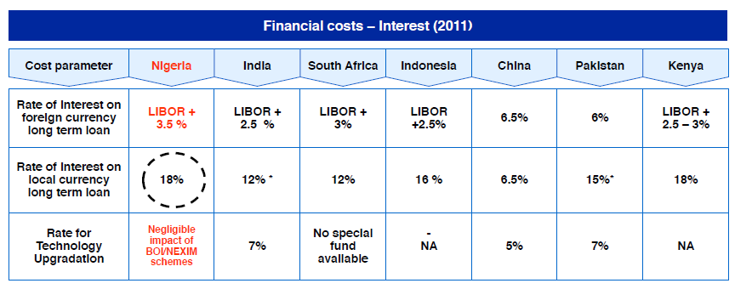
With current liquidity squeeze occasioned by the implementation of government Treasury Single Account (TSA) Policy and the implementation of the Flexible Foreign Exchange Policy following the devaluation of the Naira, local currency interest rate currently averages at 25%.

Figure 1: Comparison of Financial cost between Nigeria and some of her export Competitors
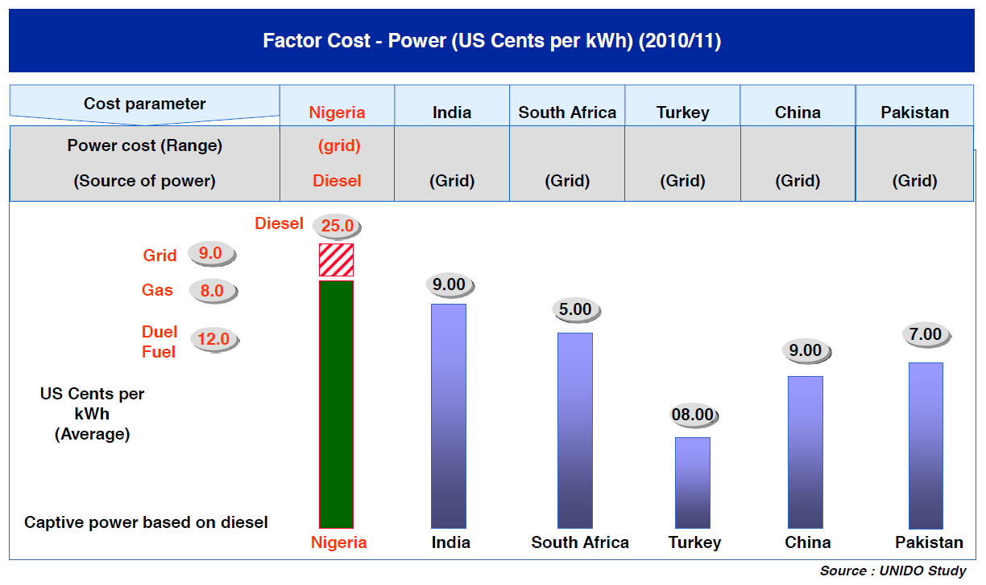

In addition to the high financial and power/energy costs, Nigerian exporters face several disadvantages due to lack of an enabling environment reflected in policy implementation bottlenecks. The Doing Business 2015 quantitative indicators on business regulations and property rights which were compared across 189 economies depicted these policy implementation bottlenecks in their ranking of Nigeria on the Ease of Doing Business; when benchmarked against other economies that compete with her in the international export market.
A high ease of Doing Business ranking means the regulatory environment is more conducive to the starting and operation of a local firm. The ease of doing business impacts directly and indirectly on the export competitiveness of exporters in any country. Nigeria’s ranking as compared with some selected countries is shown in the table below:

Table 4.2 World Bank Group: 2015 Doing Business ranking data for Nigeria and Selected countries
Ranking criteria | Nigeria | South Africa | Ghana | Botswana | China | Turkey | India
Ease of doing business | 170 | 43 | 70 | 74 | 3 | 55 | 142
Starting a business | 129 | 61 | 96 | 149 | 8 | 79 | 158
Getting Electricity | 187 | 158 | 71 | 103 | 13 | 34 | 137
Registering property | 185 | 97 | 43 | 51 | 96 | 54 | 121
Getting credit | 52 | 52 | 36 | 61 | 23 | 89 | 36
Protecting investors | 62 | 17 | 56 | 106 | 2 | 13 | 7
Trading across borders | 159 | 100 | 120 | 157 | 2 | 90 | 126
***The rankings for all economies are benchmarked to June 2014.

With the ranking in the table above, there is no gainsaying that Nigeria needs to support her non-oil exporters to cushion the impact of the identified challenges on their export businesses specifically and Nigeria’s non-oil export in general. Based on international best practices, one major path to effectively support the growth of non-oil export specifically and the economy at large is to provide a basket of incentives for non-oil exporters to cushion the inevitable challenges that they face locally.

4.2 Supporting Non-oil Export through Incentives: Examples from Other Countries
Most export-dominant economies globally develop viable baskets of incentives to support their exporters to break even in the global market place.
Thus, these countries compete more favorably in the international market-place compared to their counterparts which do not or whose incentives policies are weak and unstable. The following countries provide examples of economy-boosting export incentives that Nigeria can emulate:

- China
Based on the 2006 WTO report, China introduced an elaborate package of incentives to attract Foreign Direct Investments (FDI) and boost exports. Over 50 types of subsidies were notified to WTO. These include:
- Export tax rebate of up to 27%
- Tax holiday up to 5-10 years
- Exchange rate favorable to exporters
- Top class infrastructure (power, roads, ports) and enabling environment
- Incentives to Chinese companies who invest in export markets
- Consistent policy reviewed on 5 years basis

China became the world’s largest export nation with exports of US$ 1.6 trillion in 2010 and has remained so till date with exports of US$2.252.
- The United States of America
On January 20th, 2009 when the Obama administration was inaugurated into office, United States of America was just recovering from the economic and financial crisis that led to the loss of millions of U.S. jobs. The situation was similar then, to the present day Nigeria where the fall in oil price and corruption has impacted negatively on the economy leading to the loss of millions of Nigerian’s job, increased unemployment and endemic poverty. Like the current administration in Nigeria, the Obama’s administration had made job creation in the United States and a return to sustainable economic growth it’s topmost priority.
Recognizing the role of strengthened and sustained export development in achieving its objectives, the Obama’s administration, through the Executive Order 13534 of March 11, 2010, launched the US National Export Initiative (NEI) with the goal of doubling exports over the next five years.
The NEI was driven by the Cabinet Export Promotion Committee which reported directly to the President. Amongst other things, the NEI supported Exports by Small and Medium-Sized Enterprises (SMEs) through incentives, Federal Export Assistance, Trade Missions, Commercial Advocacy, Increasing Export Credit, Reducing Barriers to Trade and Export Promotion of Services.
Consequently, America’s export of goods and services grew astronomically such that in 2012, U.S. exports hit an all-time record of $2.2 trillion and supported 9.8 million jobs. Today, US is the third largest exporting country in the world. Nigeria and consequently, President Muhammadu Buhari’s administration, may wish to take a cue from the United States to develop a Presidential initiative focused on non-oil export.
- Singapore
Singapore is ranked Number One globally in the World Bank Ease of Doing Business scale and the 14th highest exporting country in the world. An analysis of Singapore’s Export Promotion Strategy and Economic Growth (1965-84) shows that Singapore rolled out a basket of export and investment incentives that propelled their current status.
In the first instance, new industries which qualified for ‘pioneer’ status were exempted from the 40% profits tax for a period of five, ten, or more years. Then, under the Industrial Expansion Ordinance No.2, income taxes were reduced for firms that expanded in order to produce approved export products. Thirdly, to induce investment and expansion of export-oriented industries, export incentives, introduced in 1967, provided a 90% tax exemption for 5-15 years for export profits derived from sufficient large investments.
Currently, Singapore exporters enjoy varied export incentives such as the new tax incentive, the International Growth Scheme; the Double Tax Deduction for Internationalization scheme; and the funding support for SMEs using trade agency IE Singapore's grant schemes amongst others. These incentives are at the epicenter of Singapore’s dominance in global export.
- India
India, from 2006, had aimed to double her exports in three years. As such, her Foreign Trade Policy was developed to provide a package of incentives for exporters viz:
- Duty draw back (DEPB) scheme to refund all taxes and duties on exports
- Concessional export credit at 3% subsidy
- Tax holidays up to 10 years in SEZ
- Focus product & Focus market scheme to offer higher incentives for specific products
- Sectorial incentives to labour intensive industries such as textile and leather
- Consistent policy reviewed on 5 year basis
India became the world’s 14th largest export nation with exports of US$ 220 billion in 2010 and currently stands at 19th with export value of US$ 342.5.
- Australia
The Export Market Development Grants (EMDG) Scheme
This is a key Australian Government financial assistance program for aspiring and current exporters. The scheme, administered by Austrade, supports a wide range of industry sectors and products, including inbound tourism and the export of intellectual property and know-how outside Australia. The EMDG scheme encourages small and medium sized Australian businesses to develop export markets; reimburses up to 50% of eligible export promotion expenses above $5,000 provided that the total expenses are at least $15,000 and provides up to eight (8) grants to each eligible applicant. Australia, with exports estimated at USD250.8 billion, ranks as the 23rd highest exporter globally.
- Ghana
Ghana is the 70th country globally in the World Bank 2015 Ease of Doing Business scale. The country has become an investment haven for many foreign companies which were hitherto based in Nigeria. In addition, many Nigeria indigenous companies have domiciled their operations in Ghana.
The reason for this is not far-fetched. Apart from providing a conducive environment for businesses to thrive as measured by the Ease of Doing Business criteria, the Ghanaian Government supports non-oil exports through a basket of incentives given to Ghanaian exporters. For example, The Ghanaian Export Promotion Council in association with the Ministry of Trade and Industry offers many export incentives to Ghanaian exporters, such as:
- Export Proceeds Retention Scheme: which allows exporters to exchange all (i.e. 100%) foreign exchange proceeds from non- traditional exports into cedis at competitive rates negotiated with the exporter's bankers or keep them in their foreign exchange accounts.
- Corporate Tax Rebate: which allows any manufacturer or any person, engaged in agricultural production, exporting part or all of his production, to claim tax rebate between 40% and 75% of his tax liability
- Custom Duty Drawback: This allows exporters to draw back up to 100% of duties paid on material imported to produce goods for export.
- Bonded Warehousing: That allows manufacturers to seek Customs license to hold imported raw materials intended for manufacturing for export in secured places without payment of duty.
- Up-Front Duty Exemption: This operates alongside the duty drawback system and enables exporters enjoy 100% duty exemption on imports intended to go into production for export.
These incentives have been instrumental in enhancing Ghana’s non-oil export competitiveness when compared to Nigeria
- Uganda
Although Uganda is 150th in the Ease of Doing Business ranking, Ugandan non-oil exporters are competing favorably in the global export market riding on the Government’s export incentives. The objective of the Ugandan Government export incentives is to compensate exporters for the infrastructural inadequacies and the cost of bureaucratic inertia that affect the ease of doing business and impact negatively on production cost.
The incentives are also intended to level the playing field as much as possible to render Uganda's exports competitive. Currently the following incentives are operational in Uganda;
- Foreign Exchange Liberalization: The foreign exchange regime is fully liberalized and Ugandan exporters are entitled to retain 100% of their foreign exchange earnings accruing from their export transactions
- Duty and VAT exemptions: There are no taxes charged on exports (zero rated). This is meant to reduce costs for the exporters and to make exports from Uganda more competitive
- Market Access: Ugandan products enter the European Union and USA markets duty and quota free under the Cotonou Agreement (ACP – EU) and the African Growth and Opportunity Act (AGOA) initiatives respectively. By signing to these agreements, the Ugandan Government makes exported products from Uganda into these markets more competitive compared to countries that are not signatories to such agreements e.g. Nigeria
- Zero Rating for Value Added Tax (VAT) on Exports: In Uganda, all exports of goods and services are zero rated for VAT. However, exporters are required to be VAT registered. This enables them to re-claim VAT expended on all inputs used in the process of producing and processing exports.
- Duty Drawback: The rationale for duty drawback is to enable manufacturers and other exporters to compete in foreign markets without the handicap of including costs of imported inputs in the final export price, the duty paid on imported inputs. This allows exports to draw back up to 100% duties paid on materials inputs imported to produce for export
- Manufacturing under Bond: This scheme allows manufacturers to seek custom license to hold and use imported raw materials intended for manufacture for export in secured places without payment of taxes.
All these export incentives are currently functional in Uganda. Nigerian exporters are expected to compete for certain markets with exporters from this country. What are our chances in the face of the current Ease of Doing Business ranking and the absence of the only functional export incentive in Nigeria, the EEG?
Thus, despite the infrastructural advantages and the cost-competitiveness enjoyed by their exporters, other major exporting countries, especially strong, export-led economies like China, the United States of America, Singapore, Australia, Brazil, China, and India, are still providing huge export incentives to promote exports; and Nigeria would need to act proactively so as to avoid being further marginalized in the international trade arena.

4.3 The Export Expansion Grant (EEG)
The Federal Government of Nigeria is not oblivious of the challenges faced by Nigeria’s non-oil exporters. Thus, Government has, over the years, set up various incentive schemes for companies whose businesses are export-focused. The incentives range from tax exemption to duty drawbacks (now defunct), Export Development Fund (not activated), Export Expansion Grant and Export Adjustment Scheme Fund amongst others. Of these, the only one in operation till 2013 was the Export Expansion Grant (EEG).
The EEG is a grant issued to non-oil exporters to reduce production, distribution and logistics (Production) costs which will enable them compete effectively in the international market since production expenses will naturally impact final product price. It was expected that goods from other countries with cheaper production costs would ordinarily sell cheaper, even in Nigeria, than those exported from Nigeria. The grant ranges from 10 per cent to 30 per cent of the Freight On Board value of the products being exported with a confirmation that the export proceeds have been repatriated. The grant rate scored by the exporter also depends on the categorization of the exporter among others.
Prior to the 1999 fiscal year, the EEG was paid to beneficiaries in cash. However, from 1999, the grant came in the form of Negotiable Duty Credit Certificates (NDCCs) issued by the Nigeria Customs Service. The NDCC is a negotiable instrument that can be used to settle or reduce import and Excise Duties. Accordingly, it offers the following benefits to the exporter:
- Enhances the ability of such exporters to reduce overhead costs given the potential to reduce or eliminate incidence of import duties on products used by such exporters in their production.
- Can be used as security to obtain loan from banks.
- It can be transferred from the original beneficiary to third parties (up to a maximum of three transfers) - Thus, where the exporter has no import duties payable, it could still benefit from the NDCC.
This was how the EEG operated and was administered between 2005 and 2013. In 2013, the EEG was re-designed but not long thereafter, was suspended for another review exercise following allegations of abuse. It is on record that the scheme has been suspended and reactivated eight times between 2005 and 2014. The last suspension was in January 2014.

Figure 2 Benefits of EEG
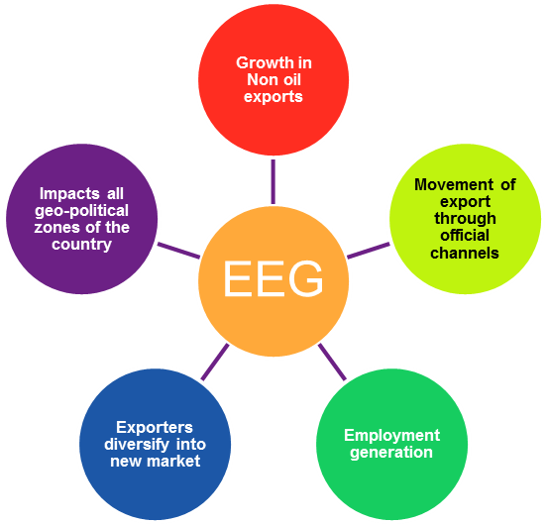
Analysis of Nigeria’s non-oil exports during the regime of the EEG scheme showed that there was remarkable improvement. For example, Non-oil exports increased by 400% under the extant EEG policy regime (2005-11) as illustrated in the chart below.
Figure 3 Impact of EEG on Non-oil Exports
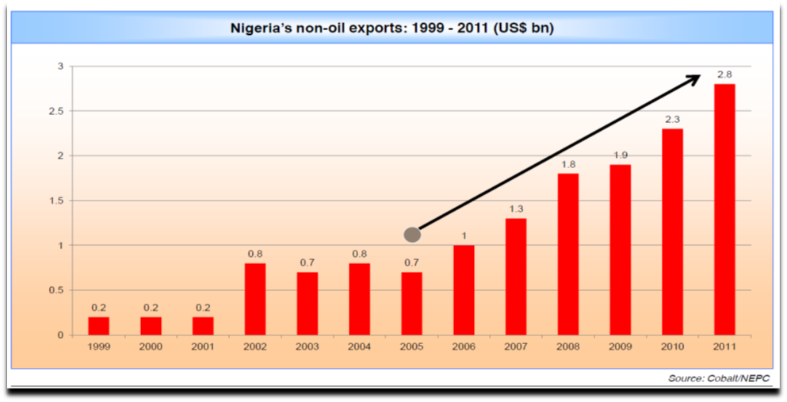

Similarly, share of non-oil exports in Nigeria’s total exports, though small, doubled within 5 years (2006-11)

Figure 4: Nigeria non-oil remittances
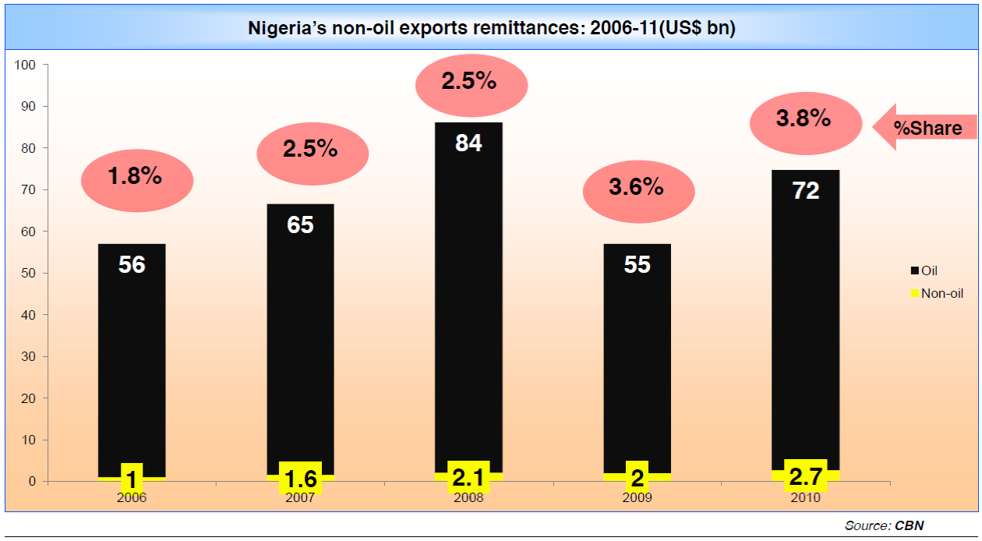
Specifically, EEG impacted largely on the Agro-allied products which drive Nigeria’s non-oil exports with Cocoa and leather contributing about 50% of total exports
Figure 5: Product wise market share of non-oil exports
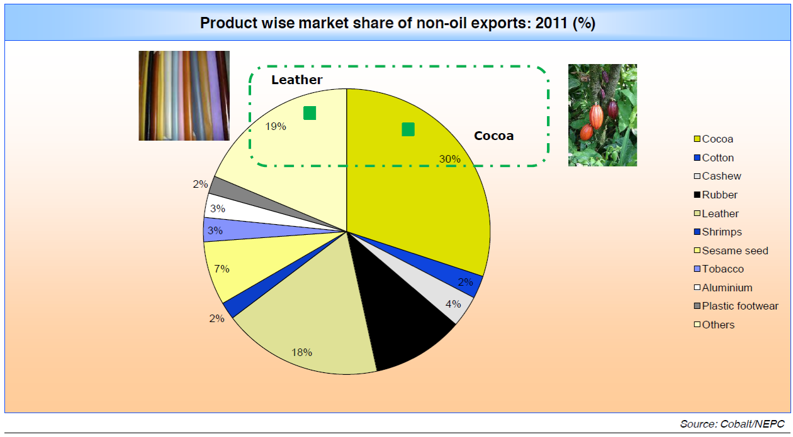
Since agriculture employs the greater percentage of Nigerians, EEG accounted for the employment of over 11 million Nigerians who are directly and indirectly employed in the agro-allied non-oil sector, mostly in rural areas.
Figure 6: Employment in non-oil sector
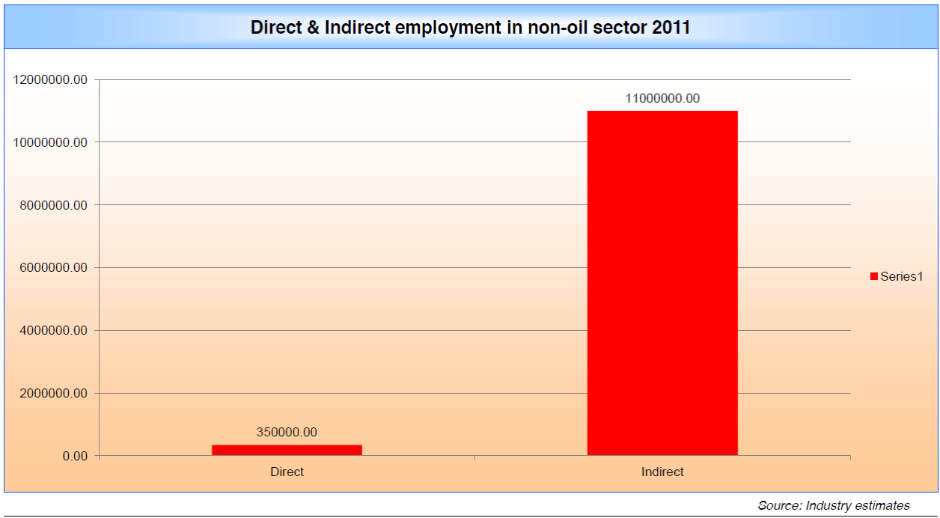
Furthermore, as depicted in the map below, EEG impacted on the lives of Nigerians in all geo political zones by impacting on the Non-oil exports sector.

Figure 7: Potential non-oil exports across Nigeria
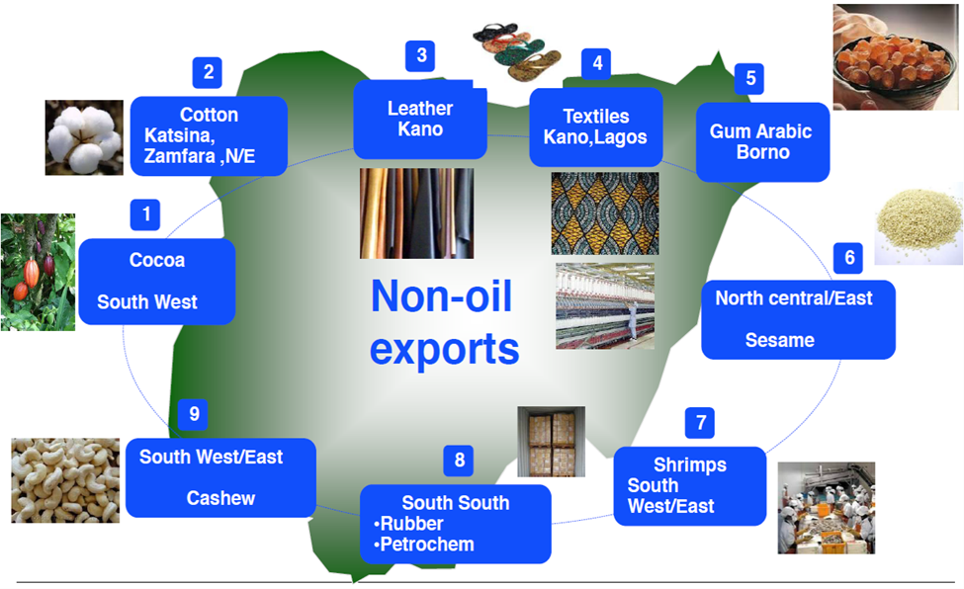
Also, EEG enabled Exporters to have diversified market base with entry to the US market in particular under AGOA.
Figure 8: Destination of Nigeria’s non-oil export
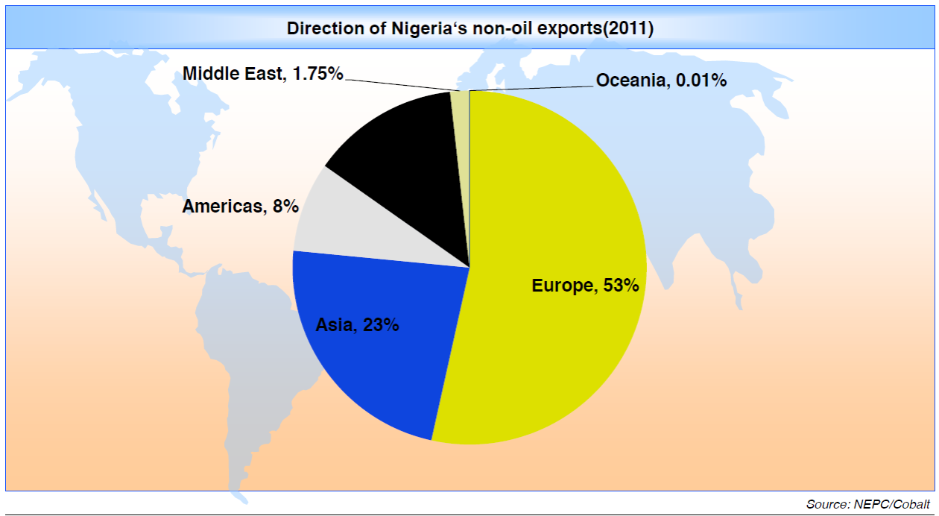

4.4 Resolving the Impasse
The non-oil sector is facing a crisis due to an arbitrary embargo imposed by the former Minister of Finance Dr. Ngozi Okonjo Iweala in Jan 2014 on the utilisation of EEG-NDCC’s resulting into a huge backlog of over =N=150 billion of NDCC’s lying unutilized with exporters and a concomitant decline in non-oil exports in 2014.

Figure 9: Value of Nigeria non-oil exports (2006-2014)
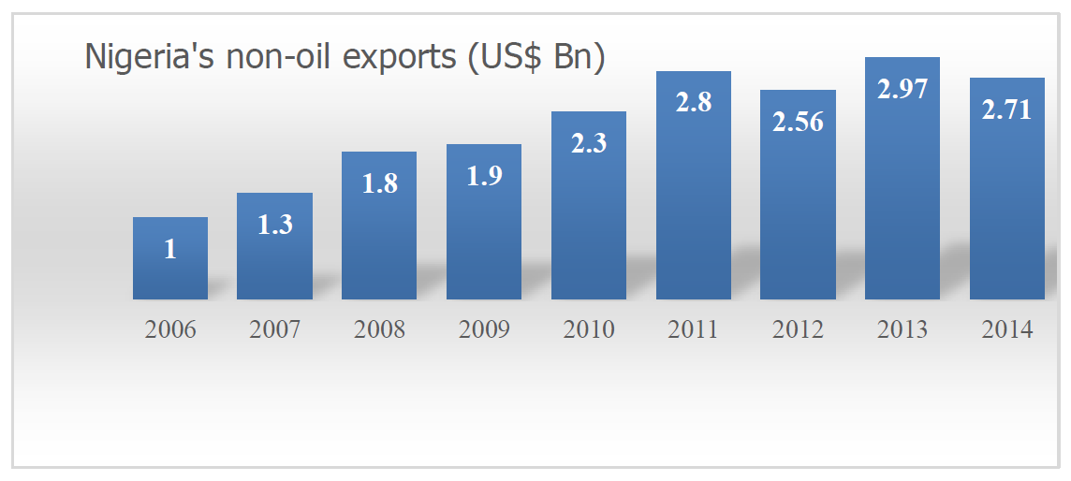

The backlog of unutilized NDCC’s has paralyzed the non-oil export sector and is affecting Nigeria’s image as a reliable trading partner. The liquidity problem faced by exporters is having a negative impact on agricultural and manufacturing sectors. Many companies have scaled down production and declared redundancy.
Besides the unutilized certificates, Nigeria Export Promotion Council (NEPC) has a backlog of claims against exports made up to 2013 and foreign exchange repatriated by the exporters as per the extant policy, which await processing by the EEG Implementation Committee. Owing to this ban, the Nigeria Customs Services (NCS) no longer honors the NDCC and this has triggered several adverse consequences including:
- Challenges of loan repayment in respect of funds borrowed by exporters from
Financial institutions for export on the strength of the NDCC.
- Incidences of bad loans in the hands of the bank since the NDCC collaterals are no longer honored.
- Potential non-competitiveness of products exported from Nigeria in the international market.
- It is expected that failure to access the EEG would impact product pricing as payment of customs and excise duties would need to be reflected in the pricing structure of exported manufactures or processed products
- Outright failure of the export business and attendant loss of jobs by the personnel employed in those non-oil export operations/businesses

Having x-rayed the factors affecting the full, continuous and sustained implementation of the EEG scheme, the following can be adopted to resolve the impasse:

4.5 Renegotiate unutilized NDCCs and Claims-in-the-Pipeline
Nigerian exporters have always demonstrated a strong understanding of the challenges faced by Government and are never averse to making sacrifices when called upon to do so.
Government must understand that until the Export Incentives and Miscellaneous Act (Cap.18) is rescinded, the EEG remains a binding contract between her and the exporting companies. The exposure profile will continue to increase until there is a firm resolution. It is therefore imperative that the new administration sets up a machinery, as urgently as feasible, to discuss and negotiate an acceptable one-time clearance for all export grants and outstanding and unutilsed NDCCs (processed and in process) for exports up till September, 2015. Conditions for mutual agreement will be set by the joint committee to be set up for the purpose.

4.6 Policy Stability and Continuity
Going forward, whilst it is appreciated that the operation of EEG has an impact on the cash flow of the Federal Government, it becomes imperative that an incentive scheme, which is consistent with the drive to improve fiscal receipts from non-oil sources without eroding the level of those receipts through cash payouts, should be developed.
Policy instability and discontinuity have crippled the non-oil export sector is affecting Nigeria’s image as a reliable international trading partner.
Figure 10: Policy on EEG (2005-2011)
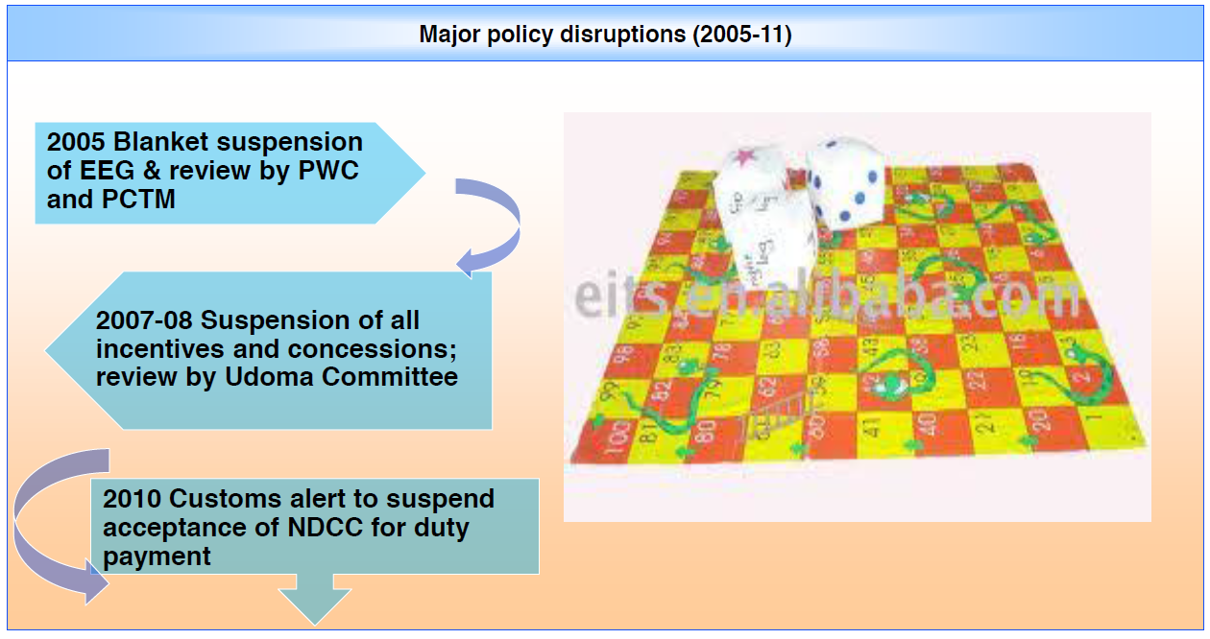

The existing policy should be continued and reviewed to make it more effective towards the realization of the new administration’s economic agenda.

4.7 Involving the State Governments
The reality of the Nigerian situation is that the production/manufacturing activities of exporters are located within the business landscape of the respective States in which they are operating. This has a direct implication for the involvement of State Governments as partners of the Federal Government in developing a non-oil export-driven economy. Extending export promotion responsibilities to States (and even the LGAs) will help to reduce cost and increase competitiveness.
Already, the NEPC Act empowers the Council to establish State Committees on Export Promotion. It is therefore desirable that, at National Council of States level, the Vice President, as head of the nations’ Economic Team, cultivates the participation of the States. NEPC, on the other hand, should be mandated to revive the State Committees.

4.8 Recommendation
- Short Term (6 Months)
Claims up to December 2013
- Impact assessment of the EEG Scheme on the economy and effect of the suspension on the export statistics: Ministry of Finance, CBN, Federal Bureau of Statistics.
- Review status of NDCCs and EEG applications:
  - Value of NDCCs held by exporters
  - Value of approved certificates awaiting signature and release by Ministry of Finance.
  - Value of EEG applications up to 2013 awaiting processing by NEPC.
- Based on above value, consider possible options to clear backlogs as follows:
  - Negotiate a percentage to be paid to all beneficiaries (between 30 to 60% based on availability of funds weighted against expected benefits to government).
  - Effect the reduction of the maximum rate to 20%(or revise further to 15%) as proposed in the EEG review and re-calculate all entitlements at the new rates. Also process all the pending applications on this basis.
  - Consider giving up one export year as a sign of good will and support to government on the condition that urgent steps are taken to restructure and resume incentives in either the existing form with review or under a new structure altogether.
- Based on the option adopted as above, agree a phased utilization of NDCCs with Nigeria Customs over a six month (or longer) period while longer term options are being finalized.
- To reduce pressure on Nigeria Customs, expand use of NDCCs to include payment of other government taxes and levies like Value Added Tax, Withholding Tax, etc
Claims from January 2014 to December 2015
Due to the stalemate in the Scheme since January 2014, NEPC has not invited Baseline Data and submission of applications from that period. To fulfill the obligations to exporters as contained under the Export Incentives Act, there is a need to urgently attend to this period while fine tuning the revised or new Scheme from 2016.
The issue of product categorization is very critical to sorting out the sustainability and affordability of the Scheme. The Group notes as follows:
- The internationally accepted product categorization platform is the Harmonized System which has three categories: finished products (20% maximum duty rate, except in cases like the ECOWAS CET where a fifth band of 35% is obtained); semi-processed products (10%) and raw materials (5%).
- While the current Weighted Average Criteria may have served its purpose, we believe it is not sustainable in the longer term especially if the focus on growing value-added exports, by implication, finished products’ exports. The existing qualifying criteria are based on the company structure rather than the product and gives room for high rates applied to non-value-added exports.
- If this scheme is to be sustained, it is recommended that government applies the same principles in determining EEG rates for the different categories of exported products as follows:
  - Finished goods – 20%
  - Semi-finished/semi-processed goods – 10%
  - Raw materials/commodities – 5%

B. Medium Term: From 2016-2018
- An Inter-ministerial Committee to urgently revisit and complete the review of the EEG Scheme - an exercise long overdue as it has been mandated by the Federal Executive Council since2010.
- The review should emphasize the right product categorization clearly giving priority to value-added exports which underpins the industrialization and diversification plans of this administration.
- Consider combining the EEG with some other export incentives as follows:
              - Finished goods exporters: 15-20% EEG + Duty Draw-back Scheme/MEIBS
            - Semi Processed: 10% EEG + Export Development Fund
            - Raw materials: 5% EEG + Export Development Fund
- Review additional ways of funding the the EEG Scheme. We are aware, for instance, of a requirement for the Nigerian maritime and Shipping Agency (NIMASA) to remit a certain percentage of its revenue to fund the Nigeria Export Promotion Council (NEPC) which is not implemented to date. Other similar options may be explored to create a revenue pool for supporting this scheme which has proven, over the years, to significantly grow the non-oil export revenue for the country.
- Make necessary annual budget for the Scheme

- C. Long Term/Ongoing:
A Clear and Sustainable Export Agenda
In the fiercely competitive international trade arena, the name of the game is support, subsidy or incentives, whichever one each country decides to call its own.
In the case of Australia, the Government’s basket of thirty-four different incentives is divided into the New Exporter Development Grants (a series of incentives to encourage entrance into export business) and the Export Market Development Grants (a set of post-shipment incentives for established exporters). Several of the other countries have adopted country-specific variants of the Duty Draw back, while some extend their incentives via tax credits.
Nigeria, through its Export Promotion Council needs to dust up the basket of incentives that were designed in 1986 and known as the Export Incentives and Miscellaneous Act. Some of those that need to be activated immediately include:
- The Export Development Fund (EDF).
This incentive would help to produce core Nigerian exporters and will focus on all pre-shipment activities including Export market Research, Production of bankable Export Business Plans, participation in overseas trade events to launch into the export market, Export-readiness capacity-building programmes, etc. Indeed, the EDF can be developed to a level of being able to elicit funding directly from all manufacturers and exporters through Corporate Social Responsibility initiatives, (as is done in the extractive industries) as well as from International donor agencies and development partners.
- The Export Credit Guarantee Scheme.
One of the most serious limitations to exporting from Nigeria is access to and high cost of export financing. Activating the Export Credit Guarantee Scheme will necessitate effective synergy between the Central Bank of Nigeria, NEXIM Bank and all Commercial Banks. The outcome promises to usher in a new lease of life to Nigerian exports and exporters.

4.9 Regular Consultation between the Government and the Private Sector
In some of the countries cited above, Exports occupy the highest priority in national economic development plans and are directly supervised by the President. Part of the provisions of America's National Export Initiative is a monthly review meeting with the President himself. In Uganda, exporters hold a monthly breakfast meeting with the President to ensure that the country's exporters are supported optimally and that her exports remain competitive. Nigerian cannot run away from such a strategy if she must derive the maximum benefits from her rich non-oil export sector.
Suggestions
- An Annual Export Conference
There is no need reinventing the wheel. Between 2010 and 2012, a Nigerian private sector outfit initiated and executed on an annual basis, the Nigerian Non-oil Export Conference, Exhibition and Awards (NNECEA). The initiative provided ample platform for discussion between Government and Private Sector on the Non-oil export sector. The event was suspended in 2013 and 2014 because of the absence of cooperation between the two key Ministries. NNECEA must be resuscitated immediately. The first consultation/dialogue should serve to set a road map for the administration with strategies and timelines for real diversification and development of viable and sustainable alternative to crude oil as mainstay of Nigeria's economy. It should therefore take place without further delay, with attendance by the highest levels of Government including the President and the Vice President who has responsibility for the economy, governors of states with export operations, as well as all Ministers directly or indirectly involved in exports.

- A Bi-annual Exporter Forum With The Economic Team:
A forum to review the export performance, challenges and opportunities between the Economic Management Team and exporters should take place twice a year. This will provide the opportunity to assess the performance and make any changes that will improve the performance by the next forum.

- A Cabinet Committee On Non-Oil Exports:
It is obvious that non-oil exports collapsed in the previous administration because of the territorial wars between the major Ministries with oversight for export trade. This administration must be assisted to avoid those destructive land mines.
The proposal is for government to constitute a Cabinet Committee comprising the Ministers in charge of Trade, Finance, Agriculture, Solid Minerals, National Planning, as well as the heads of Central Bank, Nigeria Customs Service, NAFDAC, NEXIM, Bank of Industry, Bank of Agriculture, Tourism Development, SON (with a designated Director each) and a recognized private sector export group to drive export. The Private sector should also be mandated to put its house in order by establishing an inclusive umbrella body for all non-oil export associations across the sectors. Heads of these sectorial associations would then form the new body which would, imperatively work with the Cabinet Committee.

- Impact Awareness and Export Education
The major problem that the Export Expansion Grant faced in the past stemmed from inadequate awareness or absolute ignorance of its relevance, even on the part of the Government authorities that administered it or supervised the usage of the Negotiable Duty Credit Certificates. NEPC must be mandated to conduct Impact Assessment of the EEG on an annual basis and submit reports to the Cabinet Committee, under the Chairmanship of Mr. President himself. This should commence in 2016.
- Improve Export Knowledge capacity through Training
The export value chain will be significantly enhanced through the provision of export training. This should cover all players in the Nigerian export proposition (exporters, banks and regulators, etc). To this end an export training institute can be established to drive export knowledge capacity building. The institute can be tasked with generating export-benefiting ideas and proffering solutions to export related challenges.
- Energization of NEPC
To achieve the level of concerted effort required to give non-oil export the prominence it requires and deserves, there is need for NEPC to take the lead at this time, in the advocacy for non-oil export in all ramifications. NEPC therefore needs to be energized to play a more visible and active role in ramping up export and in the administration of export incentives.

SECTION 5: SPURRING TRADE GROWTH THROUGH A NEW TRADE FACILITATION AGREEMENT

5.1 Introduction
There are several definitions of trade facilitation, all relatively similar. The term generally refers to the simplification of procedural and administrative impediments to trade (such as Customs administration, standards and technical regulations), as well as associated information flows required to move goods internationally from seller to buyer and to pass payment in the other direction. Even if there are examples of scholars who include many more issues under the banner of trade facilitation, but this course material will use the widely accepted definition adopted by the WTO, as “The simplification and harmonization of international trade procedures”. Trade procedures, in turn, are” the activities, practices and formalities involved in collecting, presenting, communicating and processing data required for the movement of goods in international trade” (WTO 1998). As shown in Figure 1, trade facilitation can be discussed within the broader policy initiatives of institutional reforms, transport facilitation, export promotion, custom modernization, electronic governance and regional integration. Trade facilitation has largely come to mean measures that seek to improve the regulatory interface between government bodies and traders at national borders.

Figure 11: Trade Facilitation and Broader Policy Initiatives
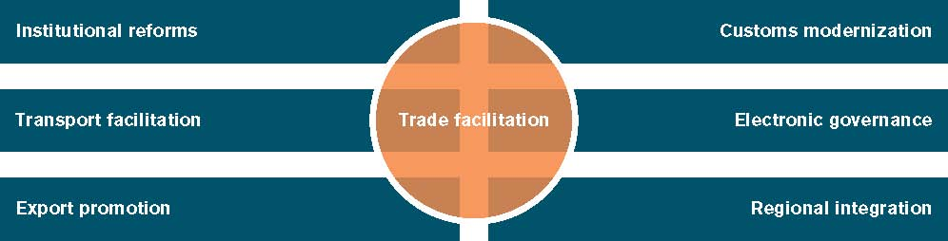
Source: WTO Secretariat

There are a number of global initiatives on trade facilitation, the most important of which is the Trade Facilitation Agreement (TFA) of the World Trade Organization (WTO). Trade facilitation is receiving increased attention at national, regional and international levels and is presently an important item in the WTO trade negotiations. It is a relatively non-contentious and promising initiative in the non-tariff aspect of WTO negotiations. It is equally incorporated in many customs modernization programs and supply chain security initiatives, where it is seen as being able to help improve controls and reduce burdens on legitimate traders. Recent aid-for-trade deals and capacity building initiatives regularly take in trade facilitation measures as part of implementation. Expenditures to support trade facilitation specific projects increased from US$101 million in 2000 to US$391 million in 2006 (WTO/OECD 2008). This is in part because trade facilitation is known to save costs. The OECD (2003), for example, calculates that each 1 percent saving in trade related transaction costs yields a worldwide benefit of US$43 billion.

Trade facilitation impacts income and welfare through three major channels. First, trade facilitation improves a country’s overall trade landscape and increases its access to the benefits of international trade. With trade facilitation, agents within a country are more able to trade with the rest of the world thus, increasing income. It changes the prices of traded goods which then are translated into prices faced by different sectors. Secondly, trade facilitation directly affects growth. This impact emanates from improved efficiency of resource use which is an outcome of reduced turnover time at ports and increased access to external resources. The weight of evidence is that increased openness to trade is good for growth. Indeed, for full benefits of tariff liberalization to be realized, it has to be accompanied by trade facilitation in the forms of simplification of procedures, provision of transport and communication infrastructure. Where this is not the case, tariff liberalization has been known to fail to generate the investment and productivity improvements needed for economic growth. Finally, trade facilitation improves government revenue. Measures such as customs reforms affect income distribution and poverty through changes in the government’s fiscal position, particularly if trade taxation is an important source of revenue. It reduces incentives for diversion, under-declaration of goods and other sharp practices that generally reduce government tariff revenues. The increase in government revenue often translates to increased ability for pro-poor expenditures.

5.2: Trade Performance of Nigeria
The behaviour of selected macroeconomic indicators suggests that the growth rate of GDP was not stable between 2000 and 2013, but moved from 5.4% in 2000 to 7.0 % in 2009 and 6.95% in 2013. Per capita income grew higher in the late 2000s compared to the early 2000s. Until 2004, an average Nigerians lived on less than $2 per day, but since 2005, it has increased, and by 2013, it was about $3.5 per day. Meanwhile, despite the success story in term of GDP and per capita income growth, the poverty level is high. For instance, in 2005, about 46 percent of Nigerians were poor because they could not afford $2 per day, but by 2013, the figure rose to over 52 percent of the populace. However, the level of literacy has improved, as it rose from 77.2 percent in 2003 to 88.7 percent in 2006 but fell slightly to about 70 percent in 2012. Secondary school enrolment rate has also improved, moving from 24.3 percent in 2000 to 42.0 percent in 2013.

The movement of foreign reserve is a reflection of the trend of current account balance that the country experienced since 2000. As can be observed, the ratio of current account balance to GDP fell from 16.2 percent in 2000 to 5.0 percent in 2003 but rose dramatically to 32.5 percent in 2005, after which there was continuous decline. Also in the financial sector, the performance of the capital market has improved. The market capitalization of listed companies in Nigeria progressed over time. As a percentage of GDP, market capitalization rose from 9.2 percent in 2000 to 17.2 percent in 2005 and then to 52.0 percent in 2007 before it fell to 21.5 percent in 2012. The marked decline experienced in 2008 and beyond was a reflection of the aftermath of the global financial crisis which began in 2007. With respect to the external sector, the share of exports in GDP which was 54 percent in 2000 fell to 38.2 percent in 2010, but rose to 55.4 percent in 2012. Among the factors could account for this instability are oil price fluctuation, lack of export diversification, and inadequate export supply response. Similarly, import share of GDP declined from 32.0 percent in 2000 to 30.4 and 34.2 percent in 2010 and 2013 respectively. The stock of external debt as a share of GDP was more than 77 percent of GDP in 2000, but declined consistently to 5.5 percent in 2007 as a result of foreign debt forgiveness that was granted to Nigeria in 2006. Subsequently, except in 2008, it has been less than 5.0 percent. The percentage share of net foreign direct investment (FDI) in GDP was very small, ranging from 2.2 percent in 2002 to 5.1 percent in 2009 and 3.4 percent in 2013. This shows that the capacity of the economy to attract foreign investment is very low. Exchange rate depreciated from US$1:N101.7 (official rate) in 2000 to US$1:N131.2 in 2005 (about five years later), and by 2013, the official exchange rate was around US$1:N156.00.

The values of Nigeria’s exports increased over the period of 2003 to 2012 with the exception of 2007 and 2009 (Table 2.1). The total value of exports in 2003 was USD24.2billion and it increased to USD144.2 billion. Between 2013 and 2015, the Nigeria’s exports had decreased. It is worthy to know that between 2014 and 2015, there was significant reduction in Nigeria’s exports.

Table 5.1: Trade Performance of Nigeria
Trade Performance of Nigeria

Year | Total Imports (Million) | GR for Imports (%) | Total Exports (Million) | GR for Exports (%)
2003 | 14,775 | 0 | 24,186 | 0
2004 | 10,889 | -26 | 38,588 | 60
2005 | 12,762 | 17 | 50,465 | 31
2006 | 22,590 | 77 | 59,316 | 18
2007 | 32,604 | 44 | 54,795 | -8
2008 | 27,753 | -15 | 81,271 | 48
2009 | 33,737 | 22 | 49,747 | -39
2010 | 44,046 | 31 | 86,522 | 74
2011 | 54,921 | 25 | 129,671 | 50
2012 | 36,047 | -34 | 144,211 | 11
2013 | 45,192 | 25 | 91,763 | -36
2014 | 46,351 | 3 | 102,721 | 12
2015 | 33,754 | -27 | 44,282 | -57
Source: ECOWAS Commission
The total value of exports of 2015 reduced by more the half of the value of the 2014. More so, the values of Nigeria’s imports increased between the period of 2003 and 2014 with exception of 2004, 2008 and 2012. It is worthy to know that the values of Nigeria’s exports were more than that of imports between the periods of 2003 to 2015.

Figure 12: Trend of Imports and Exports in Nigeria 2003 - 2015

The structure of trade shows that the country's export was dominated by oil products. As shown in Table 2.2, Oil export rose from N1, 920.9 billion in 2000 to N 7,140.6 billion in 2005 and the percentage share was from 98.7 percent to 98.5 percent within the same time interval. This implies that although Oil exports values were increasing, its share fell slightly from 2000 to 2005. In the case of non-oil export, the country realized N 24.8 billion in 2000 while it rose to N106.0 billion in 2005, with the percentage share rising from 1.3 to 1.5 percent in the respective years. In 2010, Oil export was N11.3 trillion and accounted for 96.5 percent of total exports, while non-Oil export was N 406.2 billion, constituting 3.5 percent of total exports. There was a rise in the share of non-oil export in 2013 compared to 2010-2012, while Oil export recorded slight change during the period. Overall, both Oil and non-Oil exports have been rising since 2000 but Oil exports remarkably dominated, but the share of nonoil exports have started improving from 1.46 % in 2005 to 4.78 % in 2013. This implies that government policy toward export diversification appears to have positively influenced exports of non-oil products.

Table 5.2: Structure of Nigeria’s Trade
Structure of Nigeria’s Trade

Year | Exports (fob) in billion naira |  |  |  |  | Imports (cif) in billion naira
 | Oil | Non-oil | Total | Share of oil (%) | Share of non-oil (%) | Oil | Non-oil | Total | Share of oil (%) | Share of non-oil (%)
2000 | 1,920.9 | 24.8 | 1,945.7 | 98.72 | 1.28 | 220.8 | 764.2 | 985.0 | 22.42 | 77.58
2001 | 1,839.9 | 28.0 | 1,868.0 | 98.50 | 1.50 | 237.1 | 1,121.1 | 1,358.2 | 17.46 | 82.54
2002 | 1,649.4 | 94.7 | 1,744.2 | 94.57 | 5.43 | 361.7 | 1,151.0 | 1,512.7 | 23.91 | 76.09
2003 | 2,993.1 | 94.8 | 3,087.9 | 96.93 | 3.07 | 398.9 | 1,681.3 | 2,080.2 | 19.18 | 80.82
2004 | 4,489.5 | 113.3 | 4,602.8 | 97.54 | 2.46 | 318.1 | 1,668.9 | 1,987.0 | 16.01 | 83.99
2005 | 7,140.6 | 106.0 | 7,246.5 | 98.54 | 1.46 | 797.3 | 2,003.6 | 2,800.9 | 28.47 | 71.53
2006 | 7,191.1 | 133.6 | 7,324.7 | 98.18 | 1.82 | 710.7 | 2,397.8 | 3,108.5 | 22.86 | 77.14
2007 | 8,110.5 | 199.3 | 8,309.8 | 97.60 | 2.40 | 768.2 | 3,143.7 | 3,912.0 | 19.64 | 80.36
2008 | 9,861.8 | 252.9 | 10,114.7 | 97.50 | 2.50 | 1,315.5 | 3,922.7 | 5,238.2 | 25.11 | 74.89
2009 | 8,105.5 | 296.7 | 8,402.2 | 96.47 | 3.53 | 1,068.7 | 4,047.7 | 5,116.5 | 20.89 | 79.11
2010 | 11,300.5 | 406.2 | 11,706.7 | 96.53 | 3.47 | 1,757.1 | 5,857.5 | 7,614.7 | 23.08 | 76.92
2011 | 14,323.2 | 499.5 | 14,822.6 | 96.63 | 3.37 | 3,043.6 | 7,191.6 | 10,235.2 | 29.74 | 70.26
2012 | 14,260.0 | 476.1 | 14,736.1 | 96.77 | 3.23 | 3,064.3 | 6,020.2 | 9,084.5 | 33.73 | 66.27
2013 | 14131.84 | 708.87 | 14840.71 | 95.22 | 4.78 | 2429.38 | 6378.73 | 8808.10 | 27.58 | 72.42
Source: computed using CBN Statistical Bulletin (online version, 2014)

The composition of import is quite different from that of export in the sense that while oil dominated total export, non-oil products dominated total imports. Oil import was N220.8 billion in 2000 and constituted 22.4 percent of total imports, while non-oil import was N764.2 billion, accounted for 77.6 percent of total imports in the same year. Like in the case of exports, oil import was also on the increase as it rose from the value of 2000 to N797.3 billion in 2005, while non-Oil import increased to N2,003.6 billion. From 2005 to 2007, the share of oil import was falling, while that of non-oil was rising. However, the share of oil imports was on the increase from 2009 to 2012. This suggests that during this period, the country increased its level of non-oil imports relative to oil imports.

From the above analysis, Nigeria exported more than it imported and the bulk of export was oil, while that of imports was non-oil. United States stands out as the most important market for Nigeria’s exports (Table 2.3). In the first ten destination countries for Nigeria’s products, United States was the first, followed by India, Brazil and Netherlands while United Kingdom was the fifth destination country.

Table 5.3: Nigeria’s Export to Ten Destinations in the world (US$ million)
 | 2001 | 2002 | 2003 | 2006 | 2007 | 2008 | 2009 | 2010 | 2011 | 2012
United States | 7320.8 | 5830 | 9211.3 | 26656.5 | 25157.3 | 34758.3 | 13618.2 | 29755.9 | 28326.6 | 24139.3
India | 2083.3 | 2160.9 | 2393.4 | 5507.5 | 4398.9 | 7871.5 | 4768.6 | 9068.5 | 12790 | 15895.2
Brazil | 1051.3 | 1540.9 | 1636.8 | 2503.9 | 3459.5 | 5308 | 3986.6 | 6042 | 10554.8 | 10791.5
Netherlands | 364.8 | 288.7 | 535.4 | 1528.4 | 174.7 | 3295.1 | 1339.5 | 3936.5 | 2675 | 9957.6
United Kingdom | 44.8 | 10.7 | 96.2 | 31.9 | 283.3 | 1341.7 | 1052.2 | 1267.4 | 7809.1 | 9042
Italy | 854 | 722.9 | 688 | 1469.1 | 584.2 | 2687.8 | 2080.2 | 3048.7 | 6404.7 | 8796.8
China | 127 | 73.2 | 123.5 | 4.1 | 873.3 | 268.1 | 716.9 | 1440.8 | 2525.9 | 8038.7
Spain | 1175.5 | 1020.7 | 1484.2 | 4725.8 | 717.9 | 2798.6 | 2178.3 | 2830.1 | 7407.4 | 7802
France | 1142.3 | 998.8 | 1359.5 | 3351.2 | 1971.5 | 3370.6 | 2713.7 | 3506 | 7370.6 | 5958.7
South Africa | 197.7 | 389 | 589.8 | 1064.8 | 1382.3 | 2617.6 | 1679.2 | 1858.2 | 3239.3 | 4730.8
World | 18046.1 | 18607.1 | 24078.3 | 59215.2 | 53963.1 | 81820.5 | 49937.5 | 86567.9 | 125641 | 143151.2
Source: World Integrated Trade Solutions (WITS), COMTRADE database, World Bank

In Nigeria, the main issue of concern is that existing trade-related infrastructure has not expanded at the same pace as trade needs, the growth of urban centers and the rise in population. Many businesses complain of the high cost of transporting goods to market owing to Nigeria’s inadequate road networks and trade facilitation. This has a direct impact on profit margins, business growth and the costs of goods and services for consumers. Where transport infrastructure has been somewhat improved in Nigeria and across the region, it has not been suitably integrated to enhance industrial competitiveness by improving connectivity between rural and urban centers and between towns and cities.
On the structural transformation of the economies, the initial challenges relate to poor production capacities of ECOWAS member states. Product concentration measured as share of the top three exported products and market concentration measured as the share of the top three export markets show the degree of economic diversification of countries. As shown in Figure 3, Nigeria the leading ECOWAS member state and other seven ECOWAS member states had low product and market diversification. Only four ECOWAS member states had high product and market diversification. This kind of economic and trade structure is not appropriate for a common market.

Figure 13: Product and Market Diversification of ECOWAS Member States
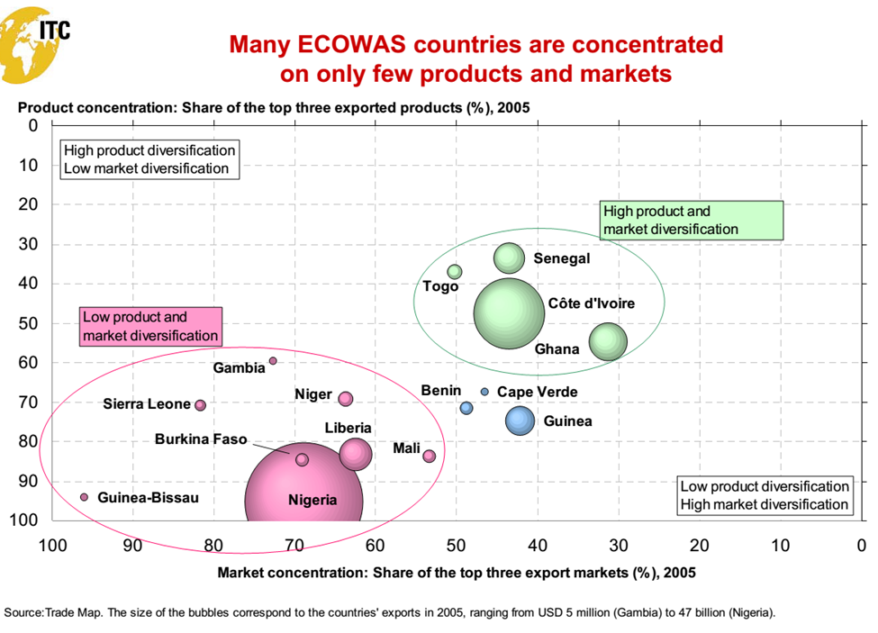

5.3 Basic Description of WTO Trade Facilitation Agreements
TFA articles can be divided into six classes. The first is transparency; Transparency Articles are built on Article X of the WTO’s GATT. This classification includes Article 1 to 5 of the TFA. Art. 1 is publication & availability of information. This is publication of trade related information through various communication means including internet. The article also allows the creation of enquiry points to answer enquiries and provide forms. Art 2 is prior publication & consultation. This provides an opportunity to comment changes to trade related regulations. It also includes consultation on a regular basis from public and private stakeholders. Art. 3 is advance rulings. This provides traders authoritative and binding information about various customs disciplines before importation/exportation. Art. 4 is related to appeal or review procedures. It provides right to administrative review and/or to judicial appeal of decisions made by Customs authority. Art. 5 regulate notification for enhanced controls or inspections and inform the importer in case of detention. The article also provides an opportunity for a confirmatory test.
The second class relates to Fees and formalities. These articles are built on the Article VIII of GATT. This class includes Article 6 to 10 of the TFA. Art. 6 is discipline on fees and charges. This provides for publication of fees & charges imposed as well as limit fees and charges to the costs of service rendered. The article also enables the periodic review of fees and charges in order to reduce number and diversity. Article 7 of the TFA relates to Release and clearance of goods. It can be regarded as the ‘two in one’. It deals with how goods would be released and cleared at the point of entry. Therefore, the article is all about customs duties, taxes, fees and charges. It provides traders the facility to submit import documents prior goods arrival and electronic payments for duties, taxes, fees and charges. The article allows the release of goods prior to the final determination of customs duties, taxes, fees and charges. It ensures set-up of a risk management system that focus controls on high-risk consignments and quick release of low-risk consignments. More so, it ensures release of goods within the shortest possible time (include outside standard business hours if required by circumstances) and measure and publish periodically the average release time of goods as well as consignment documentation compliance after release of the good. The article also set-up the facilitative procedures to expedite release of air cargo and provides additional facilitation to selected operators called ‘authorized operators’.

Art. 8 is all about border agency cooperation. It seeks to ensure cooperation and coordination between national and international border regulatory agencies (e.g. alignment of working days and hours of procedures, formalities and so on). Art 9 deals with the movement of goods under custom control. This provides the possibility to transport goods dedicated for import within the member state territory under custom control. Art 10 deals with issues of import, export and transit formalities. It sets out to minimize the incidence and complexity of import, export and transit formalities and decreases and simplifies documentation requirements.

Fees and Formalities are treated in Article 10 of the TFA. It is all about formalities connected with importation, exportation and transit. The article provides for the review of formalities and documentation requirements to minimize complexity of operations and simplify documentation requirements. It also ensures that these formalities, procedures and documentation requirements are based on international standards. The acceptance by border regulatory agencies of paper or electronic copies of the required documentation is included in the article. The article provides a set-up for a single entry point through which traders will submit, only once information to all border agencies and through which agencies will submit their responses back. The article is specific that it is not mandatory to use the pre-shipment inspections for tariff classification and customs valuation and also, that the use of customs brokers is not mandatory (i.e. the use of customs brokers shall be optional). More so, the article ensures the application of the same procedures for the release and clearance of goods at the border points throughout its territory. It provides for the importer a realistic possibility to return the goods to the exporter or re-consign (if rejected on the basis of failure to comply with SGS or technical standards). Lastly, the release of goods, without payment of duty and taxes, for importation for a predefined period and predefined purpose of use is stated in the article.
The third class relates to Transit and organizational issues. In Article 11 of TFA, freedom of transit in member countries is dealt with. The article does not apply technical regulations and conformity assessment on goods in transit (Article 11.8) and this will lead to further limits of burdensome procedure. It also provides advancement in filing and processing for goods in transit (Article 11.9) which lead to a binding commitment. The article ensures that there is limited use of customs convoys (Article 11.5) and enhance member cooperation and appoint transit coordinator (Article 11.12 and 11.13). Customs Cooperation is treated in Article 12 of TFA. It is all about information sharing and exchange. The article enables share of information on best practices in managing customs compliance and cooperate in technical guidance or assistance in building capacity. It also has provision for exchange of information and documents to verify an import or export declaration and documents that should be provided are to be true copies of the documents. Lastly, the article ensures members retain the possibility to enter/ maintain bilateral or regional agreement for exchange of customs information. This is as a result of the fact that TFA cannot alter or affect the members’ rights and obligations under these agreements.
The Trade Facilitation Agreement is designed mainly to meet businesses requirements and address what traders want. What traders want and their provisions in the TFA are as following;
- Transparent, accessible and predictable rules as well as procedures which are provided for in Art. 1 (Easily accessible trade related information) and Art. 3 (Issuance of advanced rulings).
- Standardized forms and such is provided for under Art. 10(Use of International standards in an effort to promote uniform documentation and data requirements).
- A single access point for all public services at agencies and is provided for in Art. 8 (border agency coordination), Art. 10.2 (Acceptance of copies) and Art. 10.4 (establishment of a “single window”).
- Simple, efficient and uniform formalities which is provided for in Art. 10.7 (common border procedure and documentation), Art. 10.1 (Periodic review and simplification of formalities), Art.7.4 (risk management) and Art. 7.6 (publication of release times).
- Just and rewarding system which is provided for in Art. 4 (procedures for appeal or review), Art. 7.7 (authorized operators) and Art. 6 (disciplines and fees and charges).
- Be part of the policy making process as provided for in Art.2 (opportunity to comment regulations before entry into force and regular public-private consultation and Art. 13 (set-up of National Trade Facilitation Committee (NTFC).

5.4 TFA and Implementation Challenges
Studies confirm that most developing and least-developed countries surveyed were halfway near implementation or have already implemented a number of Trade Facilitation measures and that none would be starting the implementation of the TFA from zero (UNESCAP, 2014). Until developing countries and least-developed countries submit their category B and C commitments, it will be difficult to determine accurately which countries require assistance because of the challenges encountered to implement measures of the TFA. As documented by UNCTAD (2014). Trade Facilitation is a priority for developing countries and developing countries are uncertain about the benefits of the TFA.
Some of the measures covered by the TFA are relatively easy to execute while others are difficult. Those harder to implement are (i) border agency cooperation (ii) formalities connected with importation, exportation and transit (iii) information publication and availability (iv) Lack of national coordination and political will (v) Absence of trade facilitation priority within national development planning (World Bank, 2006) (vi) Lack of legal framework (UNCTAD, 2014) (vii) Lack of resources or organizational framework, non-existent or limited understanding and knowledge of different trade facilitation measures, a lack of cooperation and mistrust between government agencies and an absence of communication between private and public stakeholders (UNCTAD 2014, World Bank 2006a).
Developing countries and least-developed countries have to decide whether and to what extent part of their limited financial resources should be allocated to trade facilitation reforms. This occurs because implementation costs are incurred immediately while benefits in terms of increased revenue and trade usually materialize completely only in the medium and long-term. The difficulties in estimating trade facilitation implementation costs are;
- Trade facilitation reform is cross-cutting by nature and is rarely carried out independently of other broader policy objectives aimed at enhancing revenue collection and reducing trade costs. There is often no specific funding allocation dedication to adoption and implementation of specific trade facilitation measures, making it particularly difficult to identify the corresponding costs.
- Implementation costs of trade facilitation can take various forms. A distinction is usually made between the initial upfront costs incurred with the introduction of trade facilities on measures, upgrade and expansion costs and the on-going operational costs.
There are eight different types of interrelated implementation costs;
- Diagnostic (Diagnostic and needs assessment costs): These are lost that arise before the actual implementation of trade facilitation. It usually involves time, national and external experts to consult collection of information and formulation of action plans.
- Regulatory (Regulatory and legislative costs): This involves adopting new legislation or amending existing legislation in order to implement specific trade facilitation measures.
- Institutional (Institutional and organizational costs): These are costs incurred when new units have to be established or existing units have to be restructured in order to perform specific trade facilitation functions more efficiently.
- Training (Human resources and Training costs): Training costs depends on whether new expert staffs are hired or whether internal or transferred staffs are trained on the job or in training centers.
- Equipment and infrastructure costs: This occurs when you constrict or acquire facilities and accommodation and install and upgrade new or additional implementation tools, including information and communication technology (ICTs) such as virtual network, automated solutions and scanners (OECD, 2009).
- Awareness-raising (Awareness-raising and change management costs): These costs arise when transparency and communication strategies are implemented to promote a greater involvement of all relevant stakeholders.
- Political (Political and resistance costs): Such costs are not readily quantifiable. This cost may arise as a result of active or passive resistance and opposition from relevant stakeholders including policy-makers, staff and the private sector to the development and implementation of specific trade facilitation measures (Duval, 2006).
- Operational and Maintenance costs: This consist mainly of the remuneration of staff or experts and the maintenance and replacement of equipment such as software or computers once trade facilitation measures have been introduced.
Implementation costs vary according to each country’s unique circumstances including its trade facilitation reforms initial state needs, priorities and desired level of ambition. For example, some countries might have existing on-going trade facilitation measures and may want to improve or expand with additional investments.
- The magnitude of implementation cost depends on the speed and pace of the implementation and the use of national or international expertise.
- The data on implementation costs collected might not be entirely representative of the actual range of the implementation costs of specific trade facilitation measures for which information is only available for a couple of countries.
- Trade facilitation measures related to transparency and the release and clearance of goods tend to involve smaller implementation costs than measure related to formalities requirements, customs automation and customs and border agency cooperation, which often entail a wider range of costs components.
- Trade facilitation measures appear on average to be less costly than broader initiatives such as customs modernization including construction and upgrading of border facilities and transport infrastructural upgrading such as road, rail and port modernization and infrastructure.
High Implementation Costs are incurred when issues of transparency and predictability are involved. Transparency-related measures relying on ICT tend to entail relatively larger implementation costs.
- Release and clearance of goods: Post-clearance audit control and risk assessment procedures appear to be the measures with the relatively highest inception costs. Both measures usually require the recruitment and training of specialized staff.
- Formalities, documentation requirements and customs automation: The establishment of a single window and customs automation systems seem to be among the most costly trade facilitation measures. High set-up costs of both measures arise from high ICT incurring hardware costs to acquire network equipment and software costs to integrate the participating agencies IT systems. Both measures also require regulatory, institutional, infrastructural and human resources changes.
- Customs and border agencies cooperation: Inception costs of projects related to integrated border management and one-stop border posts tend to be very costly also. Integrated border management programmes harmonize, streamline and simplify the border management systems of not only customs but all border management agencies such as immigration, transport, quarantine, sanitary and photo-sanitary, environment, standard and consumer protection agencies. Initiatives that further promote border management coordination through information sharing, joint use of some facilities, administrative authority delegation, cross designation of officials (Mckinden et al, 2011)
Other initiatives are;
- Establishment of one or more one-stop border posts coordinating neighbouring countries import, export and transit procedures in order to avoid duplicating regulatory formalities on both sides.
- Equipment and infrastructure including ICT and refurbishing border stations, along with training activities to ensure border management staff acquires the right expertise.
- Other trade facilitation-related areas: Areas where inception costs are likely to be low Measures related to disciplines on fees and charges, removal of consular fees, guarantee of freedom of transit routes and the abolition of escorts for goods in transit.
The WTO decided that the principle of special and differential treatment (S&D) for developing countries and least-developed countries “should extend beyond the granting of traditional transition periods for implementing commitments. The extent and timing of entering into commitments shall be related to the implementation capacities of developing and least-developed countries. Developed countries reduce and eliminate losses faced by their firms when they provide assistance and support for capacity building to developing countries and least-developed countries so that they can fully implement the TFA.
The lessons that can be learnt from different countries experience in implementing TFA shows that trade facilitation reform addresses the operational interface between government and private sector that brings together legal, economic, political, technological and management aspects. Many countries have trade facilitation reforms as part of multilateral, regional or unilateral initiatives. These experiences provide valuable information on lessons learned, successes and challenges that these countries have encountered. It is difficult to draw universal lessons from trade facilitation reforms. An approach that has proved to be successful in a given country might fail in another due to factors such as the country’s geography, level of development, legal framework, infrastructure, human resources and type and volume of trade (De Wulf and Sokol, 2005).
Different trade facilitation measures involve different types of success factors which are grouped into six categories: National ownership which involves high level political will and commitment; Stakeholder’s participation; Financial, material and human resources (adequate funding, human and organizational management); Sequencing approach (adapt a flexible implementation plan); Transparency and monitoring (adopt a communication strategy to share and disseminate relevant information to stakeholders and the general public) (UNCTAD, 2014); Adequate enabling and clear legal framework (may entail a change in laws, regulation etc.); and, Monitoring the implementation of the TFA.

5.5: Factors for the Implementation of TFA
- The most frequently reported success factor is strong high-level political will and commitment regarding the trade facilitation process reform, mentioned in 102 out of the 155 case stories. As highlighted in Figure 3.1, the relatively high number of donor countries that participated in the monitoring exercise of the Fifth Global Review of Aid for Trade identified the lack of “national coordination and political will demonstration” as one of the most important difficulties that might be encountered in implementing the TFA. Political involvement, at the ministerial, prime ministerial or presidential level, is often viewed as a manifestation of appropriation and ownership of the trade facilitation reform. Fifty-nine case stories specifically identify ownership and accountability of the government but also of the staff being brought to implement the initiative as a success factor.

Political will frequently represents the overarching factor upon which most of the other success factors rest and depend. In particular, active government involvement is often required to resolve any conflicting political priorities and allocate the appropriate levels of financial, material and human resources needed to successfully implement trade facilitation reform. In addition, a firm political commitment is often essential to overcome possible opposition and resistance by some of the stakeholders in the public and private sectors who gain from the existing system, including inefficiencies and relationships, and whose vested interests could be defused with the trade facilitation reform (Brandi, 2013; Holler et al., 2014; World Bank, 2006b).

- Financial, human and material resources are other factor for consideration. Adequate human resources and organizational management, mentioned in 61 case stories, are also reported as a critical element in enhancing the quality and integrity of staff with respect to the trade facilitation initiative (World Bank, 2006b). As highlighted in 37 case stories, trade facilitation often requires specific technical expertise. In this context, on-the-job training, including through technical assistance and capacity-building activities, is key to ensuring that the staff concerned acquire the proper skills and remain competent. Besides training and professional development, the remuneration, incentives, promotion, rotation and relocation offered to staff may have to be considered to ensure that they internalize the objectives of the trade facilitation reform and accept their (new) role and responsibilities (World Bank, 2006b). In some cases, organizational changes also have to be pursued by reallocating resources previously assigned to other tasks in order to provide greater flexibility, effectiveness and efficiency in operational matters (McLinden et al., 2011).

Figure 14: Main Success Factors Reported in Case Studies on Trade Facilitation
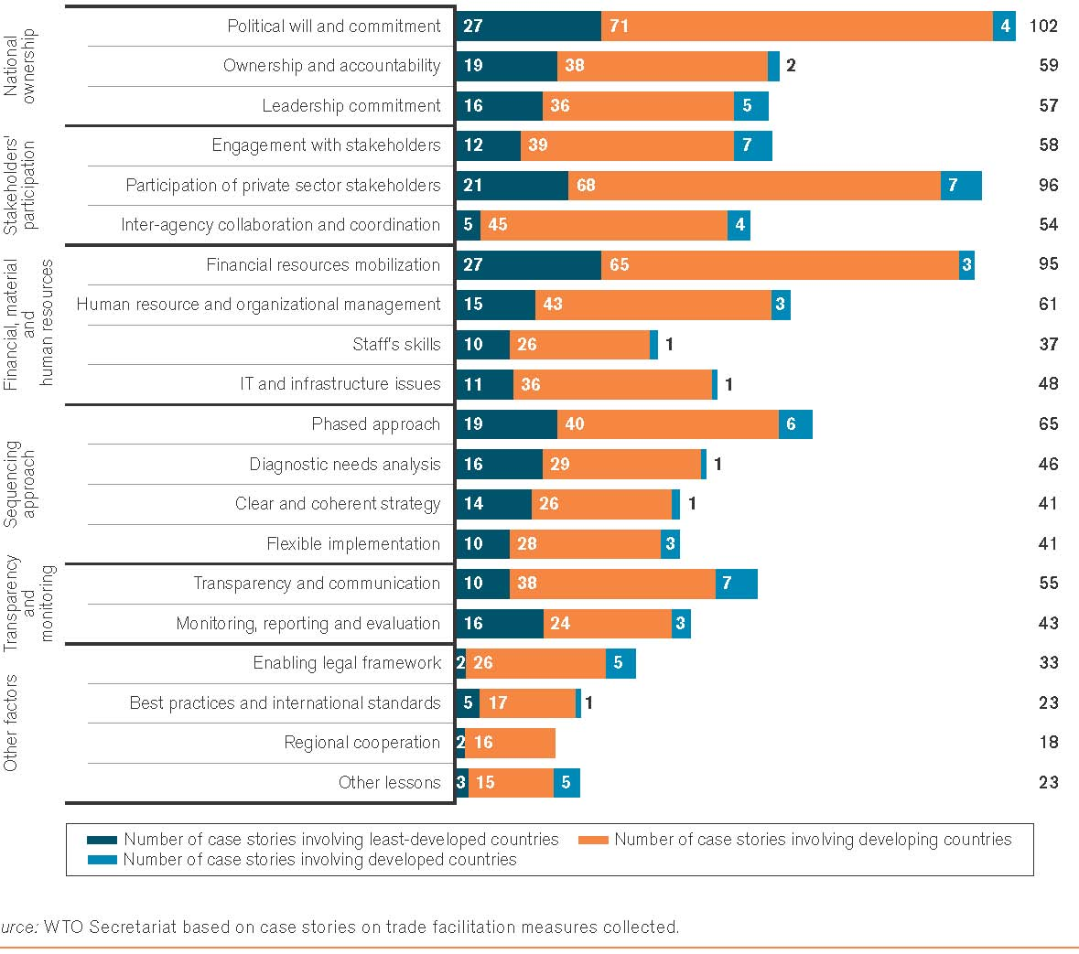:
The importance of information and communication technology and infrastructure, including equipment, to materialize trade facilitation reforms has also been highlighted in 48 case stories. In particular, the use of ICT can contribute significantly to streamlining and simplifying customs procedures and documents, as reported in many case stories on single window and paperless trade initiatives. It follows that deficiencies in ICT can prevent the full implementation of certain trade facilitation measures that tend to rely on ICT, such as single windows. A few case stories further underscore the importance of designing trade facilitation reforms attuned to the country’s actual IT capacities.
- Stakeholders’ involvement in Trade Policy Process is another factor worthy of consideration. This factor was mentioned in 58 case stories. It is the participation and commitment of relevant stakeholders in each phase of the trade facilitation initiative. As mentioned previously, trade facilitation is by nature a cross-cutting issue affecting the interest of various stakeholders in the public and private sectors. As portrayed in Figure 3.2, policy-making entities (e.g. ministries of trade, foreign affairs, finance, transport), cross-border agencies (e.g. sanitary and phytosanitary, health and environmental departments), implementing agencies (e.g. customs, port and airport authorities), the private sector (e.g. suppliers – including foreign investors – customers and intermediaries) and external donors are among the potential stakeholders involved in trade facilitation not only at the national level, but in some cases also at the regional and international level.
Figure 15: Relevant Stakeholders in TFA implementation
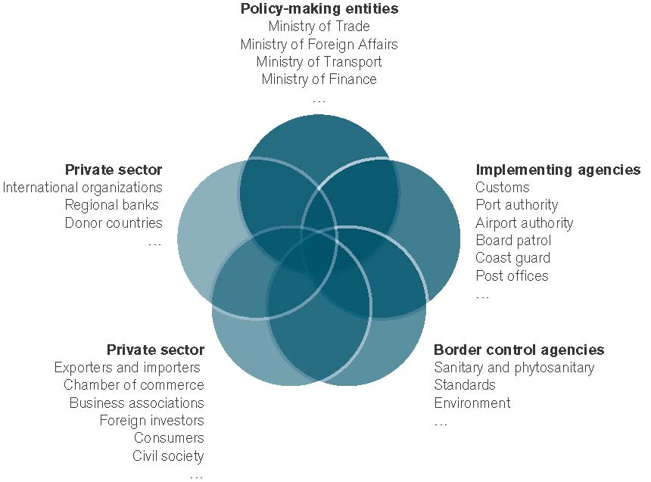
Source: WTO Secretariat
The second most reported success factor, mentioned in 96 case stories, is the active involvement and adherence of local private sector stakeholders, including chambers of commerce, business associations, and civil society engaged in trade and transport activities. As some of the first and main beneficiaries of trade facilitation reform, providing traders and businesses with the opportunity to share views and make suggestions during the needs assessment, design, implementation, and evaluation of the trade facilitation reform is critical to ensure that the initiative leads to concrete and practical benefits. Yet there is rarely a single private sector voice that naturally emerges from the different industries and sectors involved. Conflicting and opposing industry interests can therefore hamper the implementation of trade facilitation initiatives (Grainger, 2008). A few case stories underscore how important it is that the government remain neutral and not favour certain firms or industries in order not to jeopardize the broad support needed from the business community.
In the context of regional trade agreements, the quality of participation and acceptance is often a function of the relative size of stakeholders consulted. In other words, there is some inequality in participation that is a function of the size of the respective stakeholder and the decision making process at the regional level. The emergence of full customs union and prospect of common market may depend on implied political influence, of formal and informal relationships they maintain with the appropriate stakeholders and of the degree of transparency in the consultation process.
- Sequencing approach is another critical factor in implementing a successful trade facilitation initiative. This was reported in 65 case stories and it provides the justification for the need to establish and follow proper sequencing. Sufficient time is often needed between the elaboration of the trade facilitation measures and their actual implementation in order to prepare the ground, bring all stakeholders on board and build internal capacity through outreach and training activities and potential additional investment (e.g. infrastructure, IT upgrades, etc.). More generally, trade facilitation reform is often viewed as a long-term and gradual process that should not be too slow, so as not to erode the initiative’s momentum, and not too fast, so as not to exacerbate resistance and undermine the reform’s sustainability. In this context, a flexible implementation plan, mentioned in 41 case stories, can be crucial for adapting and responding to external factors, such as the global recession, that can lead to delays and change priorities. User-friendliness has also been identified in a number of case stories as an important element of successful trade facilitation reforms

As highlighted in 46 case stories, the starting point of the sequencing often takes the form of an accurate and comprehensive assessment of the trade facilitation needs and priorities of the current situation, taking into account, among other things, the country’s specific operating environment, administrative competencies, resources availability, technological levels and political system, with a view to identify the situation’s shortcomings (De Wulf and Sokol, 2005). Diagnosing needs is frequently considered as a prerequisite to be able to define not only realistic objectives but also a clear and coherent strategy tailored to the situation, as mentioned in 41 case stories. Evidence suggests that, as most trade facilitation measures are interrelated, they may fail to achieve their full potential effectiveness when the measures in question are implemented partially, in isolation and in the absence of an appropriate sequencing of measures (De Wulf and Sokol, 2005; Moïsé, 2006).

- Transparency and monitoring is a very critical factor in TFA implementation. Keeping policy-makers and relevant stakeholders, including the private sector, informed on the elaboration of a trade facilitation initiative, progress achieved, difficulties encountered and surmounted, and measures proposed to address delays and changed conditions, can also contribute to its success, as reported in 55 case stories. For instance, a number of national trade facilitation bodies have adopted a communication strategy to share and disseminate relevant information to stakeholders and the general public (UNCTAD, 2014a). Such transparency mechanisms can often foster the trust necessary to convince and obtain the support, participation and ownership of all relevant stakeholders. A number of case stories further underscore the usefulness of raising awareness and promoting trade facilitation initiatives in order to sustain the momentum and gain greater support among all stakeholders. In this regard, and as mentioned in 43 case stories, monitoring, reporting and evaluating trade facilitation initiatives can be an important success factor by keeping stakeholders informed of the results achieved, and of whether the initiative is on track or needs to be adjusted. An efficient monitoring mechanism often starts with the establishment of clear performance indicators (World Bank, 2006b). Monitoring can also be essential to secure external funding, as it is a way to assess the project’s effectiveness and convince donors (Holler et al., 2014).

- Finally, monitoring the implementation is vital in effectively reaping the huge estimated benefits of the TFA to the global economy. This will help gauge the progress that has been achieved, identify the problems that have been encountered by implementing members and assess how well the flexibilities in the Agreement for developing countries or LDCs have worked. Resources will be needed to increase capacity in developing countries to implement the TFA. To ensure that they are allocated efficiently, one needs to know what types of capacity-building initiatives are most effective, and under what circumstances. These are typically the types of questions that impact evaluation studies are best equipped to answer. There has been some work on developing methodologies for impact evaluation of trade-related interventions, including trade facilitation measures (see for example Cadot et al. (2011) and Fernandes et al. (2015)). They show promise suggesting that rigorous impact evaluation is possible even without randomized trials, which are typically considered to be the gold standard.

Good data, indicators and analytical tools are required to effectively monitor and evaluate the economic impact of the TFA. One important constraint encountered in this report is the paucity of data on implementation costs despite its obvious importance for developing countries and LDCs. This report has also made use of a number of indicators and economic tools to estimate the likely benefits of the TFA. While there is no question about their reliability and usefulness, they are by no means perfect because of, among other issues, limited country and historical coverage. This should motivate the WTO, in conjunction with other international organizations and regional development banks, to pool resources and expertise so that more and better data are collected, existing indicators and analytic tools are improved and, where necessary, new ones developed so as to effectively monitor and evaluate implementation of the TFA.

Countries have been implementing trade facilitation measures for several years and no country is starting from zero. Many of these countries are concerned about the benefits and costs of implementing TFA. The most challenging measures to implement are measures related to border agency cooperation, trade-related formalities and information publication while measures related to transparency and the release and clearance of goods tend to entail lower implementation. TFAF’s key role is to match and coordinate countries requesting technical assistance with countries supplying capacity building and technical assistance. Strong political commitment at the highest level is the most important success factor in implementing trade facilitation measures and not financial resources which is also very important.
Finally, it is important and essential to monitor implementation of the TFA once it comes into force. Suggested solutions to challenges of implementing the Trade Facilitation Agreement are
- Credible estimates of the benefits of TFA should be given to bolster support for the agreement.
- TFAF should coordinate and match developing and least-developed countries requesting technical assistance with countries supplying capacity building and technical assistance.
- Impact and evaluation studies need to be carried out to monitor the operations of the agreement (both implementation costs and economic impacts).
- Strong political support and commitment.

Section 6: Summary and Conclusion
The objective of the study was to review Nigeria export initiatives and strategies by assessing level of readiness for non-oil export push. Recommendations from the report is to inform conversations at the non-oil export retreat. The study shows that inability of the funding interventions/initiatives and incentives to significantly improve our non-oil export is an indication of the existence of other deep rooted issues that urgently needs to be addressed, issues such as having a geo-mapping across all sub-sectors of our agricultural sector with a comprehensive audit of existing production capacity and to forecast required investment with a view to determining the best way to support each sub-sector, this would provide insights into what sort of financing services is needed by each sub-sector and what combination of non-financial intervention is needed by each to thrive.
The study has been able to show that Nigeria needs to recognize the fact that the its future lies in non-oil export and there should be a coherence strategy to jumpstart export. This is one means of realising Nigeria’s vision of economic development, growth, and social peace through the introduction of measures that facilitate export. Promote efficient value addition to agriculture and industrial processes in areas of competitive advantage; promote the development of backward integration policy for creating self-sufficiency; and encourage specialization and economies of scale. In doing this, the key guiding principles should be the efficient balancing of national trade and industrial policy goals and fiscal policy goals.
In conclusion, the issues identified in this study together with other sundry watershed should be adequately addressed at the upcoming retreat.

