Bureau of Public Service Reforms

ASSESSMENT OF ACCESS TO FERTILISERS, SEEDS AND CROP PROTECTION PRODUCTS

June 2017
Table of Content
1.0 Introduction and Background 3
2.0 Methodology / Approach 4
3.0. Problems and Possible Solutions: 6
3.1 Fertilisers 8
3.2 Seeds 13
3.3 Crop Protection Products 16
4.0 Way Forward 19

Abbreviations and Acronyms
APP | Agriculture Promotion Policy
BoA | Bank of Agriculture
BoI | Bank of Industry
BPSR | Bureau of Public Service Reforms
CBN | Central Bank of Nigeria
CPP | Crop Protection Products
CSOs | Civil Society Organisations
DFID | Department for International Development
DG | Director General
FGoN | Federal Government of Nigeria
FMARD | Federal Ministry of Agriculture and Rural Development
FOREX | Foreign Exchange
MDAs | Ministries, Departments and Agencies
MDGs | Millennium Development Goals
NAIP | National Agriculture Investment Programme
NASC | National Agriculture Seeds Council
NASS | National Assembly
NCA | National Council on Agriculture
NFDA | National Fertiliser Development Agency
NGO | Non-Governmental Organisations
NIRSAL | Nigeria Incentive-based Risk-sharing System for Agricultural Lending
PERL | Partnership to Engage, Reform and Learn
PFI | Presidential Fertiliser Intervention
SON | Standards Organisation of Nigeria

1.0 Introduction and Background
Facilitating access to agricultural inputs in order to transform agriculture in Nigeria will contribute directly to one of five key executive priorities, as indicated in the National Economic and Growth Plan (ERGP) of the Federal Government. This assertion was buttressed and re-echoed by participants in a stakeholders’ forum of state and non-state actors organized in February 2017, by the Bureau of Public Service Reforms (BPSR) supported by the Partnership for Engaging Reforming and Learning (PERL); where the BPSR carried out a review of its compendium of reforms with a view to identifying areas of public service delivery that were most in need of reformation.
Initially, the forum identified 46 service delivery areas that the Bureau considered would make a significant difference in the lives of Nigerians if the mechanisms for delivering such services were reformed. These were prioritised to five key service delivery problems that were ranked by participants in order of importance. Figure 1 below shows the five priority problems that were selected:
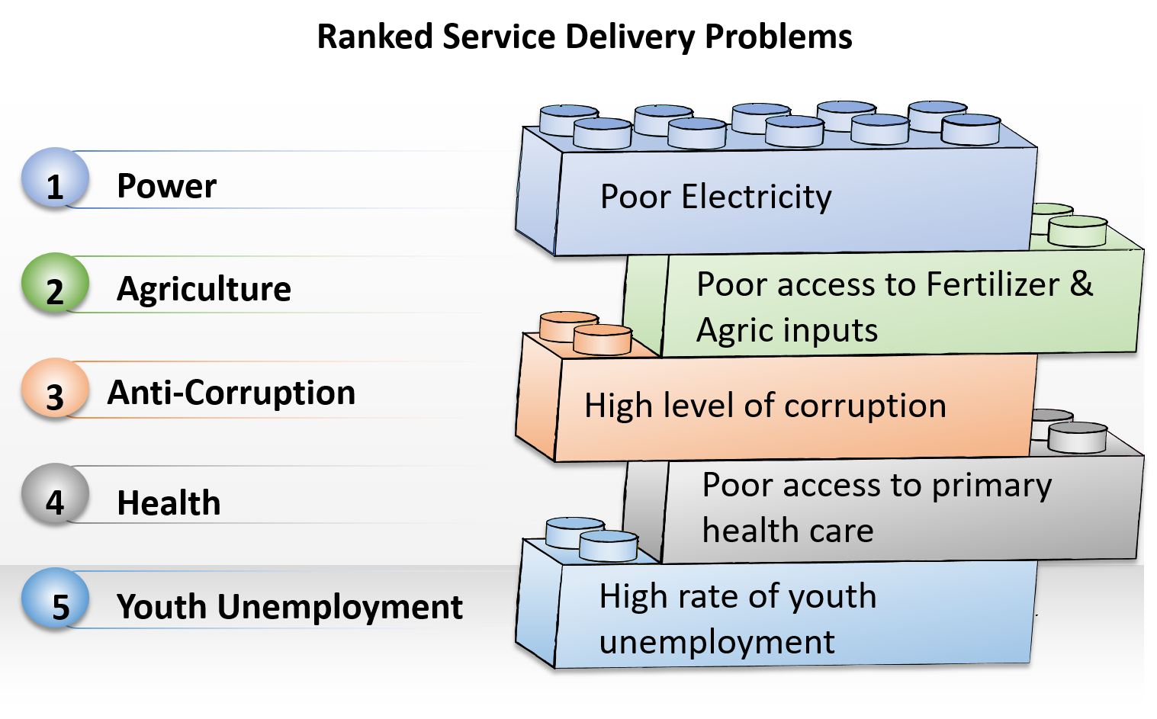
Figure 1: Ranked service delivery problems
Agriculture, and specifically access to fertilisers and agricultural inputs, was selected as one of the five priority service delivery issues to take forward, given its critical importance. BPSR, together with DFID-PERL and the Federal Ministry of Agriculture and Rural Development (FMARD), designed an intervention to interrogate the problem, and understand root causes, as part of the process of tackling the problem.

2.0 Methodology / Approach
Consultations were held with FMARD, the DFID-funded programme PropCom, sector experts and BPSR, to guide the selection of relevant stakeholders with which to further engage to interrogate the problem and decide on other critical agricultural inputs. During the process, it was found that seeds and Crop Protection Products (CPPs) were critical blockages in addition to access to fertilizer.
In March 2017, BPSR in collaboration with FMARD and DFID-PERL organised a stakeholders’ engagement forum to consider the 'root causes' of the problem of access to fertilisers, seeds and CPP. Stakeholders were carefully selected to be part of the discussion forum based on their direct or indirect relationship with the respective input process flow. In addition, states were selected from each geopolitical zone on account of historically producing high quantities of food. Priority was given to states that historically produce at least one of the crops that Nigeria aims to be a major producer of by 2020, as stated in the Agricultural Promotion Policy (APP) and the ERGP.
It was also important that participants reflected the broad spectrum of actors in the agricultural inputs sub-sector - farmers, farmers’ groups, seed producers, representatives of Federal and State Ministries of Agriculture, Central Bank of Nigeria (CBN), Bank of Industry (BoI), Bank of Agriculture (BoA), International Development Partners (IDPs) and donor programmes, research institutions, fertiliser manufacturers, blenders and distributors, and Civil Society Organisations (CSOs).
Ahead of the stakeholders’ forum, a desk review of key documents was carried out, including the government's strategic plan for agriculture, the APP. The diagram below represents the process that was undertaken to commence work on addressing the problem of poor access to fertilisers, seeds and CPP.
Process flow for Interrogating Problems

Figure 2: Process Adopted to Interrogate the Problem of Access to Fertilisers, Seeds and CPP
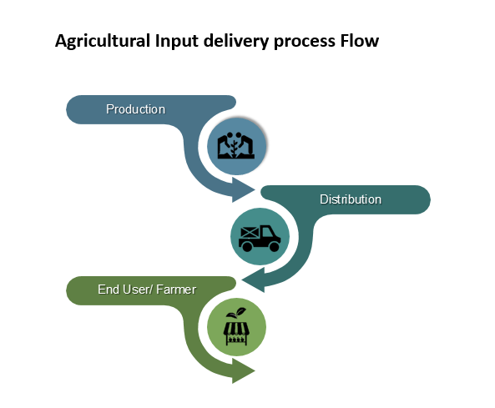
At the stakeholders’ engagement forum, the problems that are associated with access to fertilisers, seeds and CPP were considered along the input delivery process flow depicted below.

Figure 3: Input Delivery Process Flow
Problem Trees were deployed to interrogate the problems and find their root causes along the three input-delivery chains. Similarly, the attendees considered possible solutions to the identified problems using Solution Trees.
The problems and proposed solutions were further analysed. Outcomes of this analysis forms the basis of this report.

3.0. Problems and Possible Solutions:
An at-a-glance summary of the problems that were identified, and the solutions that were suggested during stakeholders’ engagement as they apply to the three agricultural inputs, are depicted below:
Problems and Proposed Solutions to Poor Access to Fertilizer
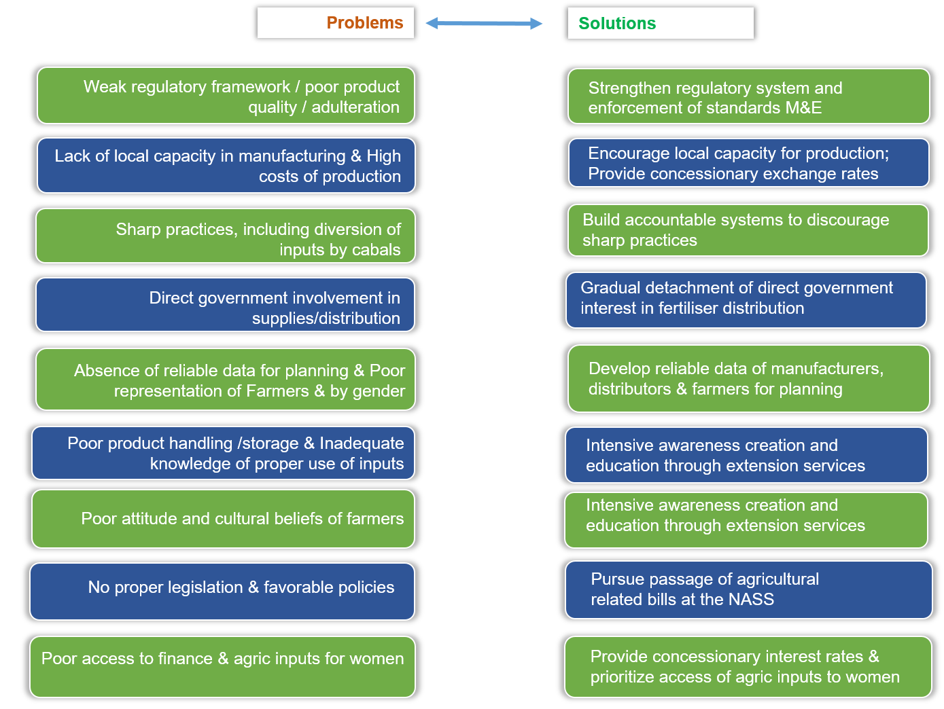
Figure 4: Problems and proposed solutions to limited access to fertilizer

Problems and Proposed Solutions to Poor Access to Seeds
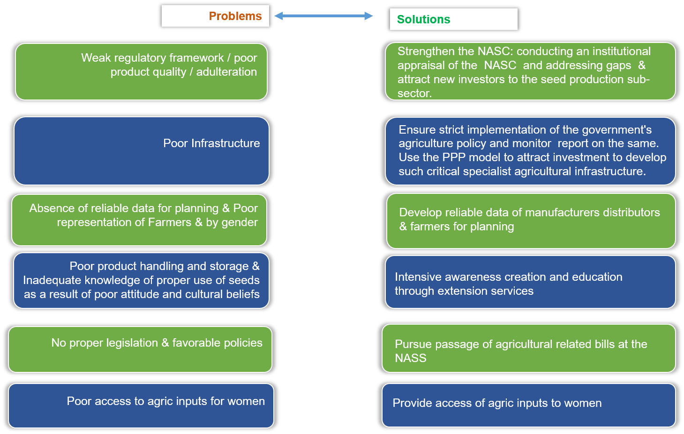
Figure 5: Problems and proposed solutions to limited access to seeds
Problems and Proposed Solutions to Poor Access to Crop Protection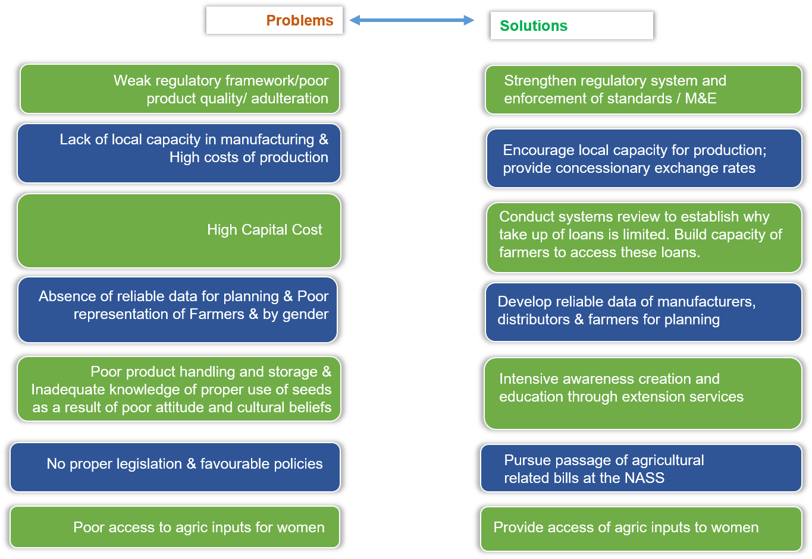
Figure 6: Problems and proposed solutions to limited access to CPP
The first point of the exercise to identify the problems and proffer possible solutions is that:
- With the exception of a couple of instances, the same problems were noted across all of the agricultural inputs - fertilisers, seeds and CPPs;
- The proffered solutions that were suggested also cut across all of the agricultural inputs.
The analysis of the critical problems and possible solutions that were provided by the syndicate groups that attended the forum are summarised in following sections:

3.1 Fertilisers
A. Absence/weak regulatory system and environment
The engagement forum concluded that the regulatory framework (legislative instrument through which the sub-sector should be managed, i.e. the National Fertiliser Bill) and environment for fertilisers is yet to be fully developed.
A National Fertiliser Bill has remained with the National Assembly (NASS) for several years, but is yet to be passed into law. At the same time, plans for a National Fertiliser Development Agency (NFDA), which would monitor and enforce compliance with the industry's standards, is also under development. However, this will only be established after the National Fertiliser Bill has been passed into law.
As a result, the fertiliser sub-sector remains largely unregulated, with Standards Organisation of Nigeria (SON) overseeing standards but with limited resources to enforce compliance.
The suggested solution to the absence of an appropriate regulatory framework is for every effort to be made, including lobbying, to ensure that both the National Fertiliser Bill and the NFDA are respectively passed into law and established at the earliest opportunity. This is necessary for the assurance that once established, industry standards will be established and enforced.
Recommendations:
R1. Finalise and pass the National Fertiliser Bill into law.
R2. Establish the National Fertiliser Development Agency.

B. Direct involvement of government in the supplies/distribution of fertilisers
It was found that, at state level, most Governors were involved in the direct distribution of fertilisers to farmers in their states. The system of Governors distributing fertilisers is considered to have the following drawbacks:
- In many cases, it is used by the Governors as a means for soliciting support and rewarding political loyalists, rather than inputs being distributed to farmers that are most in need of the products;
- The fertilisers, when they are distributed to 'real farmers' are given to them late, often outside of the appropriate time for when they should apply the fertilisers. This results in inappropriate application of the fertiliser leading to poor yield.
The FMARD needs to use the platform of the National Council for Agriculture to advocate for the gradual withdrawal of governments' direct involvement in the distribution of fertilisers.
Recommendations:
R3. FMARD to advocate for the gradual withdrawal of government's direct involvement in the distribution of fertilisers.
R4. Advocate for the removal of all subsidies on agricultural inputs and liberalise the market.

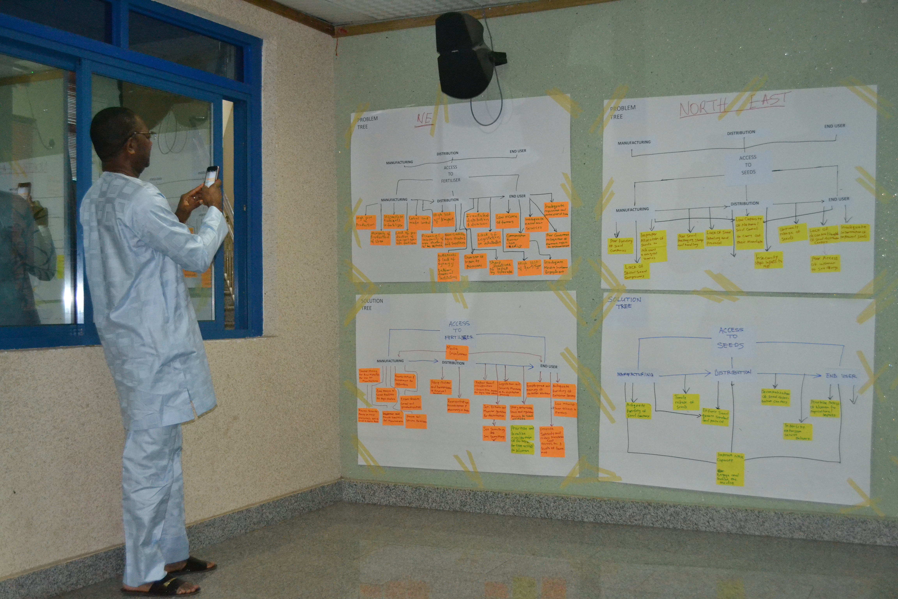
DG BPSR, Dr Joe Abah taking pictures of the problems and solutions tree of the North East syndicate group.

C. Non-availability of raw materials
The problem was characterised as one where raw materials that are required for producing fertilisers are not readily available or are in short supply. The import of this is multi-layered, with beneficiating fertiliser plants not having raw materials to continue production. That leaves them in-operational and moribund, with the overall production and supply of fertiliser being considerably reduced. The net effect of this has been that farmers are not able to use fertilisers as they should and therefore crop yields are significantly lower than expected.
In addition, it was considered that a key contributor to the shortages in available raw materials for fertiliser production is the absence of the right funding for importers who bring in the raw materials.
Solutions that were suggested for addressing the limited availability of raw materials for fertiliser production included:
- A need to invest in Research and Development (R&D) for the local production of raw materials for fertiliser production;
- Offer incentives (duty waivers, special exchange rates) to importers of raw materials for fertiliser production;
- Invest in, and reactivate the moribund fertiliser blending plants so that they are brought back into operations.
Increasing the availability of raw materials needed in the production of fertilisers is key to increasing the availability of fertilisers to farmers and the nation's chances of optimum agricultural productivity. If raw materials are sourced locally, it will also directly contribute to diversifying the economy. However, there is not much knowledge about this proposed solution.
Recommendations:
R5. Conduct a study to determine the inputs and infrastructure requirements for the local production of fertiliser and agricultural inputs.
R6. Reactivate, and bring back into production the moribund fertiliser blending plants that exist across the country.

D. Poor access to finance
Adequate financing of the agricultural sector is a key condition for achieving the government's targets for food production, food security and economic growth.
The cost of funds is prohibitively high, at double digit interest rates, making it difficult to adequately finance agricultural development activities. To counter this, the government has developed a National Agriculture Promotion Policy (APP), alongside a National Agriculture Investment Programme (NAIP) which set out how the agriculture sector's activities are to be financed. Financing for production and distribution of fertilisers and other agricultural inputs are addressed through these key documents.
The CBN has set up the Nigeria Incentive-based Risk-sharing System for Agricultural Lending (NIRSAL), and with the existence of BoA and BoI, there appear to be robust arrangements in place through which agricultural activities in the country can be financed.
However, the assessment also revealed the following key blockages:
- Poor knowledge of government's agriculture sector policies. Whilst the policies and instruments exist through which agriculture sector activities can be financed, knowledge of the policies by industry practitioners remains limited. This has made the take up of the funds to be relatively limited, with the net effect that access to finance for fertilisers and other agricultural inputs remaining limited.
- Bureaucratic and administrative systems make it difficult for beneficiaries to successfully apply/access the NIRSAL loans. It is perceived that the bureaucracy involved in applying for and qualifying for the loans has meant that only a limited number of beneficiaries have been able to successfully apply for available funds.
As a response, work needs to be done on strengthening the organisational capacity of agriculture sector actors in a way that enables them to make successful applications for the NIRSAL guaranteed funds. Improving access to finance across the delivery chain will empower farmers to afford critical farming inputs and distributors to increase availability of these inputs.
Recommendations:
R7. Organise a series of agriculture sector stakeholders (farmers, specialist bankers/financiers, fertiliser manufacturers and distributors) events to raise awareness on existing the government agriculture sector financing policy which incentivises the production of agricultural inputs.
R8. Conduct systems review to establish why take up of the NIRSAL guaranteed loans is limited, and encourage financial institutions to focus on addressing those challenges that have limited access to the funds. This should include strengthening the capacity of farmers/farmers groups through entrepreneurial development in order for them to be able to access the funds.
R9. Ensure strict implementation of the government's agriculture policy and monitor and report on the same.

E. Poor product quality/adulteration
It was generally reported at the stakeholder forum that a sizable amount of products that made their way into the market were sub-standard and often of low quality. It was also not clear whether standards for the contents in fertilisers were well set and known in the industry. On the other hand, it did not appear very clear as to which agency is responsible for standards enforcement. Majority of the attendees believe that Standards Organisation of Nigeria (SON) should be the agency to set the standard and to enforce compliance. This is because the NFDA is yet to be established.
Both the absence of established standards for the contents of fertilisers and the non-enforcement of such standards has meant that sub-standard products have found their way into the market. The consequence of that is that farmers are using the fertilisers to plant but getting less than maximal yields because the products are not what they have been marketed as. This has a significant bearing on the ultimate production and crop yields that farmers can expect. The less the use of adulterated products, the more farmers can expect increased rates of crop yield from their farms.
There is a need to set industry-wide standards, communicate those standards to stakeholders, and then to enforce compliance.
There is, therefore, a great need to establish an effective system for standards enforcement.
Recommendations:
R10. Establish, document, publish and publicise the regulatory standards for the agricultural inputs sub-sector.
R11. Deploy Enforcement Officers in the field to enforce the regulations and standards of the sub-sector.

F. Inadequate knowledge of proper use of inputs
This problem was considered to be inextricably linked to the issue of inadequate/poor agricultural extension services.
Most farmers still approach farming from a traditional and cultural viewpoint, without much knowledge of the importance of agricultural inputs. The meeting reported that most farmers, especially the rural farmers, often diluted their fertilisers so as to increase the overall area covered with fertiliser. And this would mean that they don't adhere to the usage standards set for the fertilisers.
Agricultural extension services that are key for supporting farmers to increase crop production and yields have been in decline since the early 1990s. The number of Extension Service workers was reported as being very low. Furthermore, the meeting noted that where they did exist, the Extension Service workers lacked the technical skills to deliver the service to a satisfactory level.
The poor and ineffective use of agricultural inputs by farmers continues to have a negative impact on agricultural productivity and economic development. The absence of a strong and functional agricultural extension service is also contributing to poor performance in national agricultural productivity.
Agricultural extension services need to the revamped and strengthened in order for farmers to be adequately supported to boost agricultural production.
Recommendations:
R12. Provide and strengthen agricultural extension services by:
- conducting a situational assessment of the service across the country;
- recruiting, training and deploying extension workers across the country.
R13. Develop the capacity of farmers for safe and effective handling and use of fertilisers and other agricultural inputs.

3.2 Seeds
A. Poor access to finance
As with the financing for fertilisers, government policies and initiatives exist to support the full range of agriculture sector activities, including seeds development. The problems with the access of such funds remains the same:
- Actors in the sector are not fully aware of the whole range of financing instruments that exist that they can take advantage of;
- The bureaucracy involved and the administrative requirements for accessing the funds makes it difficult for a good number of organisations to satisfactorily apply for the funds;
- Successful beneficiaries who default on paying back their loans contribute to lessening the 'appeal' and 'appetite' that commercial banks have for continuing to finance agricultural sector activities.
Research institutions, apart from the internationally funded ones, are generally under-funded. This leaves them with not enough resources to have the product development ideas that would ultimately require financing.
As with the financing for fertilisers, the lack of knowledge and understanding of the financial instruments that are available in the market continues to leave organisations without the finances that they could ordinarily access to boost their productivity. Consequently, very little new seeds development and production is taking place.
The consequence of that is that food production (both in volume and variety) remains poor, or is at least not performing, as it ordinarily would do if seeds were being developed continuously. The lack of finance is a critical problem, as it addresses the problem of access to fertilizer as well as seeds.
Recommendations:
R7. Organise a series of agriculture sector stakeholders (farmers, specialist bankers/financiers, fertiliser manufacturers and distributors) events to raise awareness on existing government agriculture sector financing policy which incentivises the production of agricultural inputs.

B. Absence/weak regulatory system and environment
There is a National Agricultural Seed Council (NASC) in place with the mandate for the overall development and regulation of the National Seeds industry. The rules and standards that the NASC has established to regulate the seeds sub-sector are not widely publicised for all interested parties of the sub-sector.
Attendees of the agricultural stakeholders’ engagement forum described the sub-sector's environment as being one with a proliferation of uncertified and undocumented seeds companies. It was reported that there is poor to weak monitoring of seeds production companies. As a result, there is little assurance for all the seeds that farmers can purchase in the market.
There is poor funding of agricultural research institutions across the country. This, in turn, limits the level of funding available for Research and Development for the development of diverse varieties of seeds.
In addition, findings from the engagement with stakeholders revealed that there are not enough seed breeders and seed producers in the industry, in terms of numbers involved in production as well as the diversity in types of seeds produced. There are also no seed multiplication units; and no designated land for product trials and testing. These conditions make investors’ entry into the sub-sector less attractive.
The existence of a large number of unregistered and undocumented seed companies suggests that the NASC is not as effective in carrying out its mandate as it should be. It is also likely that these unregistered seed companies are supplying seeds into the market that do not conform to any standards set by the NASC.
In addition to the point above, lack of publicity in the subsector about rules and standards is likely having the effect of different sector actors 'doing what they want' as they are unaware of such standards. The resultant effect is that, in practical terms, no uniform standards for seeds are in effect in the sector.
Special measures and schemes need to be established to attract additional investors into the seed sub-sector.

Recommendations:
R14. Strengthen the NASC by:
- Conducting an institutional appraisal of the NASC;
- Addressing the institutional weaknesses identified from the institutional appraisal.
R15. Consider and create a conducive environment to attract new investors to the seed production sub-sector.

C. Poor attitude and cultural beliefs of farmers
Findings from the stakeholders’ forum highlighted the problem of the majority of farmers, especially the poor and rural ones, still engaging in poor cultural and traditional agricultural practices - recycling/re-use of old seeds and resistance to the use of improved seeds. These stem from historical practices that rural farmers had always applied.
Farmers were also reported to be generally lacking in knowledge of how to handle and store seeds. This lack of education by farmers on seed handling and storage means that they largely handle and store seeds poorly, which results in their experiencing financial losses due to damages to the seeds.
Poor levels of education of farmers on the application and handling of seeds is a further indication of how inadequate agricultural extension services and support to farmers has been.
Farmers need capacity building around seed handling, storage, and use.
Recommendations:
R13. Develop the capacity of farmers for safe and effective handling and use of fertilisers and other agricultural inputs.

D. Poor infrastructure
There is a general lack of specialist agricultural infrastructure - no temperature-controlled storage facilities and poor distribution facilities and outlets across the country. This has meant that the shelf life of seeds has been quite reduced where these facilities and equipment do not exist. This is more relevant for distributors who are meant to keep seeds stock in locations that are closer to the farming communities.
Absence of specialist agricultural infrastructure and facilities means that products (seeds) are unable to have long shelf lives. Holding of seeds is therefore likely to lead to economic losses that stem from loss or damage of the seeds.
Most farms and farm communities have very poor access roads. This obviously makes it difficult for such farms to get the amount of agricultural inputs that they require if those have to be transported there by large trucks. In practice, the slightly larger farmer ends up having to 'grade the roads' that lead to the farms, while the small farmer finds 'ingenuous' ways to transport supplies to their farm sites.
Incentive strategies need to be devised and implemented which would attract private sector investment in the provision of this critical specialist infrastructure.
Recommendations:
R9. Ensure strict implementation of the government's agriculture policy and monitor and report on the same.
R16. Use the Public Private Partnership (PPP) model to attract investment to develop such critical specialist agricultural infrastructure.

3.3 Crop Protection Products
A. High Capital Cost
It was found that the amount and range of CPP in the market is limited. This is attributed to all of the following:
- High cost of producing CPPs. This is due to the high cost of finance (interest rates) as well as high foreign exchange rates which limit the amount of raw materials that can be imported. This is turn means limited production and supplies to the market at high prices. Invariably, it also means that fewer people would be able to purchase the products at market prices. The high cost of production has also meant that they are limited producers and importers in the sub-sector.
- Poor and none specialist storage facilities for CPPs means that limited stocks are held in order not to incur financial losses due to products going bad.
- High costs of production for CPPs has accounted for the limited availability of the products in the market.
The limited supplies in the market have, in turn, led some of the industry's players to indulge in the practice of adulterating the products, as a way of trying to get more margins for their spend. This often ends up as misapplication of the product, along with the negative results that come with misuse of the products - less than effective control of weeds leading to less than optimum crop yields.
Recommendations:
R8. Conduct systems review to establish why take up of the NIRSAL guaranteed loans is limited and get the financial institutions focussed on addressing those challenges that have limited access to the funds. This should include strengthening the capacity of farmers/farmers groups through entrepreneurial development in order for them to be able to access the funds.

B. Absence/weak regulatory system
Some attendees of the stakeholders’ forum suggested that SON is, or should be responsible for setting standards for the sub-sector.
Others further reported that the quality of CPPs were generally poor and sub-standard, with a lot of products in the market being adulterated products. There is limited monitoring and inspection of CPP products in the market.
The regulatory environment for the sub-sector, like other sub-sectors, appears unclear with roles and responsibilities of agencies not clearly set, nor publicised for the benefit of interested parties. A review needs to be conducted to establish and communicate the management arrangements of the sector.
The presence of sub-standard products in the market suggests a weakness in the regulating and enforcing of standards in the sub-sector. This may be the result of a lack of organisational capacity and/or the complete absence of an effective regulatory agency.
Recommendations:
R10. Establish, document, publish and publicise the regulatory standards for the agricultural inputs sub-sector.
R11. Deploy Enforcement Officers in the field to enforce the regulations and standards of the sub-sector.

C. Inadequate knowledge of proper use of inputs
As with fertilisers, there is generally poor knowledge of how to handle and use CPPs. This is compounded by the fact that farmers and other actors are ignorant of the safety issues and hazards associated with CPPs.
Poor handling of CPPs often exposes users to health risks and would suggest that the product is not used optimally. A lot of waste and degradation of the product is bound to occur on account of poor handling and use.
Poor use of the products will mean less than expected results - crop yields not up to what could be expected if agro chemicals were applied correctly. Agricultural extension services have a significant role to play in educating farmers on the handling and use of CPPs.
Across all inputs, the role of extension workers also works to provide support to farmers on the right use of CPP. The right use of inputs works to make a huge difference in the crop production.
Recommendations:
R13. Develop the capacity of farmers for safe and effective handling and use of fertilisers and other agricultural inputs.

4.0 Way Forward
The recommendations that are set out below should be considered, approved and driven by FMARD's senior management team. The highlighted recommendations represent the ones that the analysis considers most crucial for addressing the issue of access to fertilisers and agricultural inputs in the short term, across the country.
BPSR shall offer its support and technical assistance to FMARD in the implementation of the report's recommendations, especially those recommendations that are aimed at reforming government systems and processes.
A technical team will need to be established within FMARD to consider the report's recommendations and to develop an action plan for implementation. The action plan will have to be reviewed bi-annually to assess progress against implementation. Where necessary, adjustments will have to be made to the action plan where it is felt that new strategies may yield more positive results.

R1. Finalise and pass the National Fertiliser Bill into law.
R2. Establish the National Fertiliser Development Agency.
R3. Hon Minister, FMARD to advocate for the gradual withdrawal of government's direct involvement in the distribution of fertilisers.
R4. Advocate for the removal of all subsidies on agricultural inputs and liberalise the market.
R5. Conduct a study to determine the inputs and infrastructure requirements for the local production of fertiliser and agricultural inputs.
R6. Reactivate, and bring back into production the moribund fertiliser blending plants that exist across the country.
R7. Organise a series of agriculture sector stakeholders (farmers, specialist bankers/financiers, fertiliser manufacturers and distributors) events to raise awareness on existing government agriculture sector financing policy which incentivises the production of agricultural inputs.
R8. Conduct systems review to establish why take up of the NIRSAL guaranteed loans is limited and get the financial institutions focussed on addressing those challenges that have limited access to the funds. This should include strengthening the capacity of farmers/farmers groups through entrepreneurial development in order for them to be able to access the funds.
R9. Ensure strict implementation of the government's agriculture policy and monitor and report on the same.
R10. Establish, document, publish and publicise the regulatory standards for the agricultural inputs sub-sector.
R11.Deploy Enforcement Officers in the field to enforce the regulations and standards of the sub-sector.
R12. Provide and strengthen agricultural extension services by:
- conducting a situational assessment of the service across the country;
- recruiting, training and deploying extension workers across the country.
R13. Develop the capacity of farmers for safe and effective handling and use of fertilisers and other agricultural inputs.
R14. Strengthen the NASC by:
- Conducting an institutional appraisal of the NASC;
- Addressing the institutional weaknesses identified from the institutional appraisal.
R15. Consider and create a conducive environment to attract new investors to the seed production sub-sector.
R16. Use the Public Private Partnership (PPP) model to attract investment to develop critical specialist agricultural infrastructure.

Bureau of Public Service Reforms

